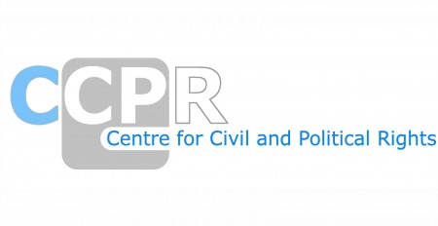

NGO REPORTS FOR THE SESSION-TURKMENISTAN
SESSION-137th

*As of 20th March 2025

ORGANISATIONS AND REPORTS
Conscience and Peace Tax International (CPTI)
Cotton Campaign
International Fellowship of Reconciliation (IFOR)
The European Association of Jehovah’s Witnesses
Turkmen Initiative for Human Rights (TIHR) and International Partnership for Human Rights (IPHR)

