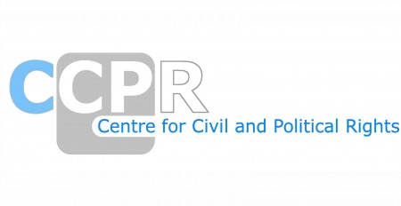

NGO REPORTS ON THE LIST OF ISSUES-TURKMENISTAN
SESSION-137th

*As of 20th March 2025

ORGANISATIONS AND REPORTS
Conscience and Peace Tax International (CPTI)
Freedom Now
Human Rights Watch
International Fellowship of Reconciliation (IFOR)
The European Association of Jehovah’s Witnesses
The European Association of Jehovah’s Witnesses - Annex
Turkmen Initiative for Human Rights (TIHR) and International Partnership for Human Rights (IPHR)

