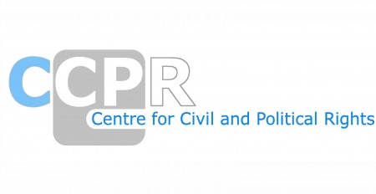

NGO REPORTS ON THE LOIPR-JAPAN
SESSION-136th

*As of 20th March 2025

NAMES OF ORGANISATIONS AND REPORTS
Amnesty International's submission to the UPR
Amnesty International's submission to the UPR - Human rights law and discrimination against LGBT people in Japan
Association of the Indigenous People in the Ryukyus
Attorney Team for Victims of Illegal Investigation against Muslims
FIDH - International Federation for Human Rights - Center for Prisoners' Rights
Global Initiative to End All Corporal Punishment of Children
Human Rights Association for Korean Residents in Japan
Human Rights Now
Japan Civil Liberties Union
Japan Federation of Bar Associations (JFBA)
Japan National Group of Mentally Disabled People
Japanese Association for the Right to Freedom of Speech (JRFS)
Joint NGO Report on the Conspiracy Law MINDAN (Korean Residents Union in Japan)
Society for Abolishing the Family Registration System and Discriminations against Children Born out of Wedlock (AFRDC)
Solidarity Network with Migrants Japan (SMJ)
The International Movement Against All Forms of Discrimination and Racism
The Japanese Workers’ Committee for Human Rights – JWCHR
Women's Active Museum on War and Peace (WAM)

