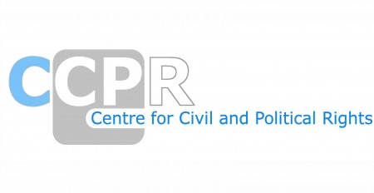

NGO REPORTS FOR THE SESSION-KYRGYZSTAN
SESSION-136th

*As of 20th March 2025

NAMES OF ORGANISATIONS AND REPORTS
Asia-Pacific Association of Jehovah's Witnesses and European Association of Jehovah's Witnesses
Asia-Pacific Association of Jehovah's Witnesses and European Association of Jehovah's Witnesses - ANNEX
Conscience and Peace Tax International (CPTI)
ECOM - Eurasian Coalition on Health, Rights, Gender and Sexual Diversity, LGBT organization "Labrys”, and Initiative Group "Myrzayim"
Equality Now, the Human Rights Movement, Bir Duino-Kyrgyzstan (BDK), Public Association “Ensan Diamond” and PA “Alga”
Forum 18
Human Rights Watch
International Association for Human Rights Advocacy Geneva (IAHRAG)
International Fellowship of Reconciliation (IFOR)
International Partnership for Human Rights (IPHR), Legal Prosperity Foundation (LPF) and CIVICUS
Justice for Journalists Foundation (JFJ) and School of Peacemaking and Media Technology in Central Asia
Open Viewpoint Public Foundation
PU "Kyrgyz indigo"
Strategic Decisions Public Foundation
TrialWatch

