Freedom of Religion or Belief  Guiding Questions for  Monitoring International Human Rights Law |  | Name of monitoring NGO(s)  - …  - …  - …  - …  As of DAY / MONTH / YEAR

This form was developed as a tool to assist stakeholders in monitoring the protection of freedom of thought, conscience, religion or belief (FoRB), as enshrined in the international human rights law, especially the Article 18 of the International Covenant on Civil and Political Rights (ICCPR). ICCPR Article 18 protects the freedom of all individuals to have, not to have, or to change their thought, conscience, religion, or belief. This encompasses all matters of thought and theistic, non-theistic, and atheistic beliefs, including the right not to profess any religion or belief at all.

The Guiding Questions in this form are designed to assist the identification of violations of ICCPR Article 18 in general as well as its various components, such as the freedom to have or adopt a religion or belief, to manifest one’s religion or belief, and the liberty of parents to ensure the religious and moral education of their children, and the determination of what information should be collected and reported to the Human Rights Committee and other relevant bodies.

This form should be used in conjunction with the CCPR Centre’s publication “Freedom of Religion or Belief: A guide for Monitoring International Human Rights Law,” a useful tool for all actors - in particular, civil society organizations and human rights defenders working on the protection of FoRB.

Freedom of thought, conscience, religion or belief – in general

GUIDING QUESTIONS | YES/NO
Are there any laws, policies, customs, or practices in your society that restrict your freedom of thought, conscience, religion, or belief? | YES NO
IF YES, please answer the follow-up questions below:

Which laws, policies, customs, or practices restrict your freedom of thought, conscience, religion or belief, and how?

Are there any individuals or groups in your society whose freedom of thought, conscience, religion, or belief is protected or restricted differently from those of others? | YES NO
IF YES, please answer the follow-up questions below:

Who are the individuals or groups whose freedom of thought, conscience, religion or belief is protected or restricted differently from others, and how?

Has your State or Government taken any measures derogating from Article 18 of the ICCPR? | YES NO
IF YES, please answer the follow-up questions below:

What kind of measures are taken by your State or Government to derogate from Article 18 of the ICCPR, and on what grounds?

- Freedom to have or adopt a religion or belief

GUIDING QUESTIONS | YES/NO
Can you freely choose which religion to follow? | YES NO
Can you freely change your religion? | YES NO
Are you able to choose not to hold any religion at all? | YES NO
Has your State or Government taken measures to protect your freedom to have or to adopt a religion or belief of your choice? | YES NO
IF NO to any of the questions above, please answer the follow-up questions below:

What barriers or limitation do you face when choosing or changing your religion or belief, adopting atheistic view and/or choosing not to follow any religion or belief?

What kind of measures would your State or Government need to take to protect your freedom to have or adopt a religion or belief of your choice?

- Freedom from coercion that would impair the right to have or adopt a religion or belief

GUIDING QUESTIONS | YES/NO
Are you being forced to follow a certain religion or belief against your will? | YES NO
Are you being forced to abandon your religion or belief against your will? | YES NO
IF YES for any of the questions above, please answer the follow-up questions below:

Who – e.g., State agents or family members – is forcing you to follow a certain religion or abandon your religion, and how?

What – such as laws, practices, or traditions – is forcing you to follow a certain religion or abandon your religion, and how?

Do you face disadvantages or barriers – such as to education, employment or public services – if you do not follow the religion or belief recognized by the State or adopted by the majority of society? | YES NO
IF YES, please answer the follow-up questions below:
What are the disadvantages or barriers that you face if you do not follow the religion or belief recognized by the State or adopted by the majority of society?

Would you gain advantages or benefits if you adopted the religion or belief recognized by the State or adopted by the majority of society? | YES NO
IF YES, please answer the follow-up questions below:

What are the advantages or benefits of following or adopting the religion or belief recognized by the State or adopted by the majority of society?

- Freedom to manifest one’s religion or belief

GUIDING QUESTIONS | YES/NO
If measures have been taken by the State authority that limit freedom to manifest a religion and belief, are those measures:
- Prescribed by law with clear definitions and precise criteria for the limitation of the freedom to manifest one’s religion? | YES NO
- Necessary for and proportionate to the protection of public safety, order, health, morals, or the fundamental rights of others? | YES NO
- The least intrusive, meaning there are no less harmful alternatives that would equally protect public safety, order, health, morals, or the fundamental rights of others? | YES NO
- Applied without any discriminatory purpose or impact on particular groups (e.g., there is no specific group particularly affected by the restriction without good reason)? | YES NO
- Equally protecting the safety, order, health, morals or fundamental rights of everyone without any unjustified distinction (there is no particular group unjustifiably left out)? | YES NO
IF NO to any of the questions above, please answer the follow-up questions below:

Which measures are restricting FoRB and in what way?
Which law provides the basis for the restriction, and in what manner?
What part of the restriction is unnecessary, disproportionate, or unjustified in light of its purpose of protecting public safety, order, health, morals or the fundamental rights of others, and in what sense?

Which groups are discriminated against or particularly affected by the restrictions, and in what way?

Which groups are left out from the scope of protection, and in what way?

- Liberty of parents to ensure the religious and moral education of their children

GUIDING QUESTIONS | YES/NO
Does public education in your country have subjects related to religion or ethics that are NOT given in a neutral or objective way? | YES NO
IF YES, please answer the follow-up questions below:

What are subjects related to religion or ethics in the public education and why do you think they are not neutral or objective?

Does public education in your country include instruction in a particular religion or belief against the wish of parents, legal guardians, or children? | YES NO
IF YES, please answer the follow-up questions below:

How is instruction in a particular religion or belief included in the public education?

Do parents or legal guardians face any difficulty to give their children religious and moral education of their choice? | YES NO
IF YES, please answer the follow-up questions below:

What are the difficulties parents or legal guardians face to give their children religious and moral education of their choice, and if any, what kind of alternatives are available?

Do children face any difficulty to receive religious and moral education of their choice? | YES NO
IF YES, please answer the follow-up questions below:

What are the difficulties children face to receive religious or moral education of their choice, and if any, what kind of alternatives are available?

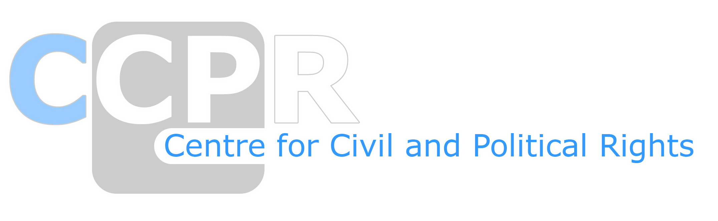
Centre for Civil and Political Rights (CCPR)
t: +41 (0)22 332 25 53
e: info@ccprcentre.org
a: 1, rue de Varembé - CP 183 - CH-1202 Geneva
www.ccprcentre.org

