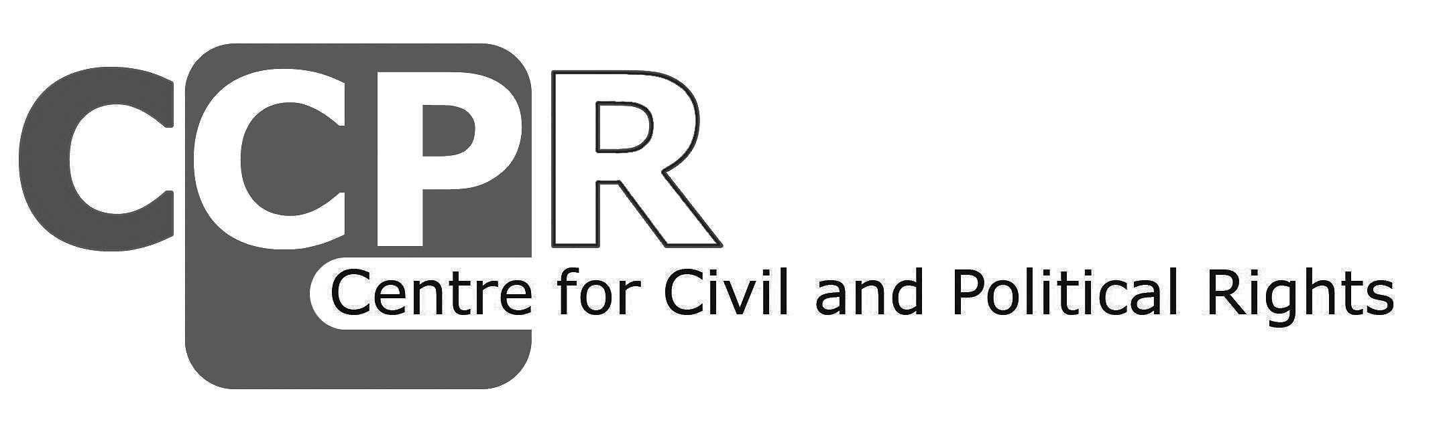

Frequently Asked Questions regarding NGO participation
in the UN Human Rights Committee’s sessions

How can NGOs participate at the UN Human Rights Committee’s sessions?
The UN HR Committee examines State reports during its sessions held in Geneva. The examination is done in a public meeting through a dialogue with the representatives of the State party concerned. NGO representatives can attend these public meetings and observe the examination of the State concerned. In addition, representatives of NGOs can participate in the formal and informal briefings to interact with the Committee members in advance of the examination.

What can NGOs do when attending the public meeting as observer?
NGOs cannot take the floor during the formal examination of the State report in the public meeting. However, by attending the examination as observer, NGOs can directly follow the dialogue between Committee members and State delegation in its original language or one of the working languages of the Committee through official and simultaneous interpretation. NGOs are allowed to use social media such as Twitter and Facebook during the public meeting to disseminate information. NGOs can also informally approach Committee members during the breaks to provide information regarding specific issues of concern raised during the State examination.

Who can attend the public meetings as observer?
The observation of public meetings is open to all interested civil society representatives as long as they register and apply for the accreditation before deadline and approved. Civil society representatives wishing to attend the public meetings in Geneva DO NOT need the consultative status with UN ECOSOC. Civil society representatives can register and apply for accreditation online through CSO-Net: http://goo.gl/JM6Uoi. Specific deadline for registration and application for accreditation is set for each session and announced in the “Information Note for NGOs” published on the Committee’s website. Relevant information can also be found at CCPR Centre’s website. Requests for registration / accreditation made after the deadline will not be accepted. CCPR-Centre is not in a position to help civil society representatives to request accreditation. For any question about this procedure please contact the Committee’s Secretariat (ccpr@ohchr.org).

What is the NGO formal briefing?
The formal briefing is an opportunity for NGOs to address the Committee in a private closed meeting within the Committee’s official schedule (specific time is set out in the Committee’s programme of work). It is usually organised in the beginning of a week for all the States being examined in that week. It is chaired by the president of the Committee and conducted in the working languages of the Committee with official simultaneous interpretation (English, French and Spanish). As it is in a private closed meeting, only the Committee members, Committee’s secretariat and concerned NGOs can attend. Usually 20 – 30 minutes are allocated for the briefing of one country, where NGOs deliver brief oral statements. The exact time allocated for each NGO speaker varies depending on the total number of speakers as well as topics / focus of their statements. If time allows, Committee members might ask questions to NGOs at this briefing while NGOs might be asked to provided answers to the questions posed by the Committee members at the end of the formal briefing, otherwise NGOs can do so in the informal briefing (see below).

What can NGOs do in the formal briefing?
Based on the information provided in their reports, NGOs can draw the attention of Committee members to the issues of their main concern, update the Committee members about changes in the situation since the submission of NGO reports, and collect concrete questions from the Committee members in advance of the review of the State concerned. Given the limited time, it is usually more effective for NGOs to coordinate each other and deliver joint statement covering broader topics. NGOs who cannot be physically present in the formal briefing can ask other NGOs who are participating in the briefing to also address their concerns, or, in case of national NGOs, request CCPR Centre to deliver their statement on their behalf.

Who / which NGOs can participate in the formal briefing?
Only representatives of NGOs that have submitted written reports to the Committee can participate in and deliver statements at the formal briefing. NGO representatives wishing to participate in the formal briefing need to contact CCPR Centre before deadline, so that they can be included in the list of speakers (info@ccprcentre.org). A specific deadline for the request to participate in the formal briefing is set for each session and announced in the “Information Note for NGOs” published on the Committee’s website. In addition, NGO participants / speakers in the formal briefing also need to register and apply for the accreditation before respective deadline through CSO-Net http://goo.gl/JM6Uoi (for deadline and other relevant information on registration, please see above “Who can attend the public meetings as observer?”). Please note that the deadline for requesting participation in the formal briefing is different from, and usually set earlier than, the deadline for registration and accreditation. The NGO speakers for the formal briefing need to be physically present in the briefing room and submit the text of their statements in advance of the briefing. No participation via Skype is possible, and no videos, photos, Power Point presentations or any type of graphic material is allowed at the formal briefing. Only oral statements are permitted.

What is informal briefing?
Informal briefing is a meeting between NGOs and Committee members, organised and facilitated by CCPR Centre upon the request of NGOs, for States being examined by the Committee. It is usually organised for an hour in the lunch break immediately before the concerned examination of the State. A separate room other than Committee’s conference room is designated for this briefing. No interpretation is provided, unless participating NGOs bring / arrange interpreters on their own. As it is not a formal meeting scheduled in the Committee’s official programme of work, participation of all Committee members is not guaranteed. However, usually many interested members, especially those who have asked questions at the formal briefing, attend the informal briefing. Representatives of NGOs who cannot be physically present at the briefing can also join / speak at the informal briefing via skype depending on the necessity and possibility.

What can NGOs do in the informal briefing?
Based on the information provided in the NGO reports to the Committee and following the formal briefing, it is a unique opportunity for NGOs to answer the questions posed by the Committee members during the formal briefing, and further engage in direct interaction with them to clarify questions and issues and highlight main concerns of NGOs. It is also advisable that participating NGOs coordinate themselves and agree upon three to five issues priority issues, which can be suggested to the Committee members in the informal briefing for inclusion in the Committee’s follow-up procedure.

Who / which NGOs can participate in the informal briefing?
The informal briefing is open for all the interested representatives of NGOs that have submitted reports to the Committee on the concerned State. Representatives of NGOs who cannot be physically present at the briefing can also join / speak at the informal briefing via skype depending on the necessity and possibility. NGO representatives wishing to participate in the informal briefing need to contact CCPR Centre before deadline (same as the one for the formal briefing). Participants for the informal briefing, except those participating via skype, also need to register and apply for the accreditation before respective deadline through CSO-Net http://goo.gl/JM6Uoi (for deadline and other relevant information on registration, please see above “Who can attend the public meetings as observer?”).

