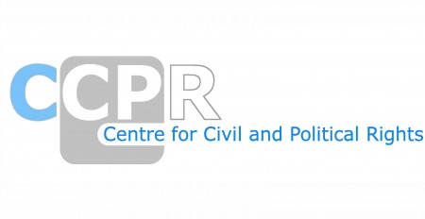

NGO REPORTS ON THE LIST OF ISSUES-ETHIOPIA
SESSION-136th

*As of 20th March 2025

NAMES OF ORGANISATIONS AND REPORTS
Lawyers for Human Rights (LHR)
Conscience and Peace Tax International (CPTI)
Consortium of Ethiopian Human Rights Organisations (CEHRO), Ethiopian Human Rights Council (EHRCO), Association for Human Rights Council (AHRE), Center for Justice (CJ), Lawyers for Human Rights, Vision Ethiopia Congress for Democracy (VECOD), Ethiopian L
Development by Unity and Brotherly Action for the Future (DUBAF) and Center for International Human Rights (CIHR) of Northwestern Pritzker School of Law
International Trade Union Confederation (ITUC)
La Coordination des Association et des Particuliers pour la Liberté de Conscience (France) and Human Rights Without Frontiers (Belgium)
Maat for Peace, Development & Human Rights
Oromo Legacy Leadership and Advocacy Association (OLLAA)
The Advocates for Human Rights
The Advocates for Human Rights and The World Coalition Against the Death Penalty

