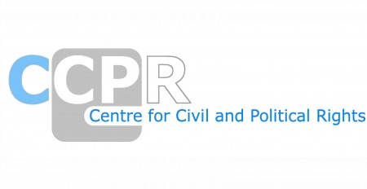

NGO REPORTS FOR THE SESSION-EGYPT
SESSION-137th (March 2023)

*As of 20th March 2025

ORGANISATIONS AND REPORTS
Access Now and the Tahrir Institute for Middle East Policy (TIMEP)
Amnesty International
Arab Organization for Human Rights (AOHR)
Committee for Justice (CFJ), DIGNITY, Egyptian Front for Human Rights (EFHR), Egyptian Initiative for Personal Rights (EIPR), EgyptWide for Human Rights, EuroMed Rights, International Service for Human Rights (ISHR), REDRESS, Women's International League
Conscience and Peace Tax International (CPTI)
Egyptian Organization for Human Rights (EOHR)
El Hak Foundation for Freedom of Expression and Human Rights
Forum for Development and Human Rights Dialogue (FDHRD)
International Commission of Jurists
Lawyers for Lawyers Foundation
Maat for Peace, Development, and Human Rights
Minority Rights Group International (MRG)
National Association for the Defense of Rights and Freedoms
Partners for Transparency
The Advocates for Human Rights, The World Coalition Against the Death Penalty, and Reprieve
The Egyptian Center for Women's Rights (ECWR)

