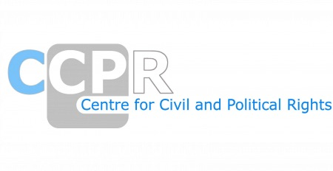
NGO REPORTS FOR THE SESSION-CANADA

*As of 24th April 2025
Organisations | Download
INTERNATIONAL CIVIL LIBERTIES MONITORING (ICLMG) | View document
Aboriginal Title Alliances | View document
African Canadian Legal Clinic’s | View document
Amnesty International | View document
Amnesty International - Executive summary | View document
CANADA WITHOUT POVERTY/CANADA SANS PAUVRETÉ | View document
Canadian Civil Liberties Association (CCLA) | View document
Canadian Federation of University Women | View document
END IMMIGRATION DETENTION NETWORK | View document
END IMMIGRATION DETENTION NETWORK - I | View document
FAFIA's submission on other issues regarding the fulfillment of women's civil and political rights in Canada | View document
Franciscans International | View document
Franciscans International, Franciscans of Western Canada & Ordo Franciscanus Saecularis Canada Sisters of Mercy (NGO), Mercy International Association: Global Action Blue Planet Project of the Council of Canadians UNANIMA International Sisters of Charity Federation International Presentation Association of the Sisters of Presentation of the Blessed Virgin Mary Congregation of the Mission NGO Mining Working Group | View document
Global Initiative for Economic, Social and Cultural Rights | View document
Human Rights Watch | View document
ILGA North America | View document
International Civil Liberties Monitoring Group (ICLMG) | View document
International Fellowship Of Reconciliation (IFOR) | View document
International Human Rights Program | View document
Joint - ESCR-Net, the Social Rights Advocacy Centre and the Charter Committee on Poverty Issues | View document
Joint Submission by FAFIA and the Native Women's Association of Canada on murders and disappearances of Aboriginal women and girls. | View document
KAIROS Shadow Report | View document
la Commission des droits de la personne et des droits de la jeunesse du Québec | View document
Ligue des droits et libertés du Québec | View document
Special Supplement on Murdered and Missing Indigenous Women in British Columbia | View document
Statement - Lil’wat | View document
The BC CEDAW Group | View document

