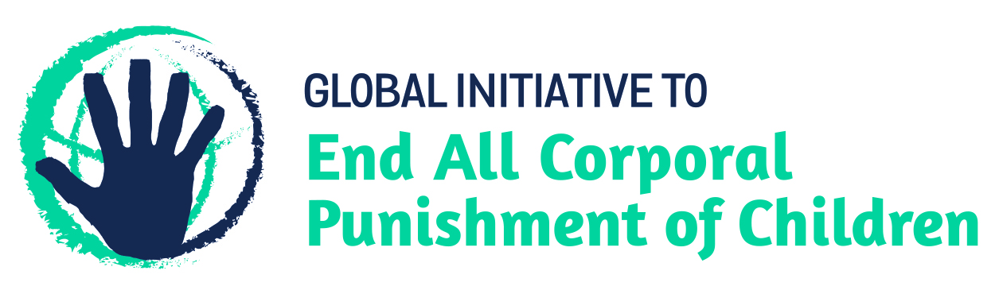
BRIEFING ON THE USA FOR THE HUMAN RIGHTS COMMITTEE, COUNTRY REPORT TASK FORCE, 125th session (March 2019)
From the Global Initiative to End All Corporal Punishment of Children, January 2019
This briefing describes the legality of corporal punishment of children in the USA. In light of the obligation under international human rights treaties to prohibit all corporal punishment of children, the global commitment to ending violence against children – including corporal punishment – in the context of the 2030 Agenda for Sustainable Development, the recommendations of the UN Secretary General’s Study on Violence against Children, and those made to the USA by the Human Rights Committee and during the Universal Periodic Review, we hope the Human Rights Committee will:
- raise the issue of corporal punishment of children in its List of Issues Prior to Reporting for the USA, in particular asking what steps are being taken to enact legislation explicitly prohibiting all corporal punishment of children, in all settings including the home, and repealing all legal defences; and,
- in its concluding observations on the USA’s fifth state party report, recommend that legislation is immediately drafted and enacted to explicitly prohibit all corporal punishment of children, in all settings including the home, and repeal all legal defences for its use, throughout the territory.

1 The legality of corporal punishment of children in the USA
1.1 Summary: Corporal punishment of children in the USA is unlawful as a sentence for a crime but it is still not fully prohibited in every state in the home, in alternative care and day care settings, in schools and in penal institutions.
1.2 Home (lawful): Corporal punishment is lawful in the home in all states. State laws confirm the right of parents to inflict physical punishment on their children and legal provisions against violence and abuse are not interpreted as prohibiting all corporal punishment in childrearing. In Minnesota, examination of several laws led some legal experts to conclude that corporal punishment is not permitted in that state, but according to the legislation a parent, legal guardian or caretaker may use reasonable force to restrain or correct a child (Sec. 609.379. [Cr.]) and the Minnesota Court of Appeal has overturned convictions for physical abuse involving corporal punishment.
1.3 In June 2015, the Massachusetts Supreme Judicial Court, in a case review concerning corporal punishment of a child by her parent, issued a judgment overturning the original conviction for assault and battery and including “guidelines” for the administration of corporal punishment. The ruling set out the following “framework”: “… we hold that a parent or guardian may not be subjected to criminal liability for the use of force against a minor child under the care and supervision of the parent or guardian, provided that (1) the force used against the minor child is reasonable; (2) the force is reasonably related to the purpose of safeguarding or promoting the welfare of the minor, including the prevention or punishment of the minor’s misconduct; and (3) the force used neither causes, nor creates a substantial risk of causing, physical harm (beyond fleeting pain or minor, transient marks), gross degradation, or severe mental distress. By requiring that the force be reasonable and reasonably related to a legitimate purpose, this approach effectively balances respect for parental decisions regarding the care and upbringing of minor children with the Commonwealth’s compelling interest in protecting children against abuse. By additionally specifying certain types of force that are invariably unreasonable, this approach clarifies the meaning of the reasonableness standard and provides guidance to courts and parents.” In the same state, a Bill is under discussion aimed at encouraging parents and caregivers to refrain from using corporal punishment (Bill H3647). The Bill was discharged in September 2016 to the Committee on House Rules.
1.4 In August 2017, the Supreme Court of Utah reversed the decision of a juvenile court which had found that parents that had spanked their children using a belt were guilty of abuse under the Utah Code. The Supreme Court highlighted that the juvenile court had failed to prove that the spanking had caused “harm” to the children as defined in the Utah Code (“physical, emotional, or developmental injury or damage”), instead stipulating harm as a natural consequence to the spanking. The Supreme Court also objected to the juvenile court’s adoption of the per se rule that “hitting a child with a belt or strap or another object is abuse” as too broad and potentially applying to inoffensive situations such as “throwing a pillow or a rolled up pair of socks at a child”, or “hitting a child with a Nerf sword playfully as part of a game”.
1.5 The American Academy of Pediatrics (AAP) published a policy statement in November 2018 calling for the education of parents on positive and effective parenting strategies ​and​ the elimination of physical and humiliating punishment, including verbal abuse​.
1.6 Alternative care settings (partially lawful): Corporal punishment is prohibited in all alternative care settings in 40 states and the District of Columbia.
1.7 Day care (partially lawful): Corporal punishment is prohibited in all early childhood care and in day care for older children in 36 states.
1.8 Schools (partially lawful): There is no prohibition at federal level of corporal punishment in all public and private schools. In 1977, the US Supreme Court found that the Eighth Amendment, which prohibits cruel and unusual punishment, did not apply to school students, and that teachers could punish children without parental permission. Corporal punishment is unlawful in public schools in 31 states and the District of Columbia, though in some of these there is no explicit prohibition. Corporal punishment is unlawful in public and private schools in Iowa and New Jersey. It is lawful in public and private schools in 19 states.
1.9 The Ending Corporal Punishment in Schools Bill 2015 (H. R. 2268) would prohibit all corporal punishment, defined as “paddling, spanking, or other forms of physical punishment, however light, imposed upon a student” (s12); it was sent to Committee stage on 12 May 2015 but failed to progress through to enactment.
1.10 Penal institutions (partially lawful): The 1977 Supreme Court ruling (see above) stated that the Eighth Amendment protected convicted criminals from corporal punishment. However, we have been able to identify only around 30 states which have prohibited by law all corporal punishment as a disciplinary measure in juvenile detention. In many others, policy states that corporal punishment should not be used but this has not been confirmed in legislation. The American Correctional Association’s standards for juvenile detention facilities call for “written policy, procedure, and practice [that] protect juveniles from personal abuse, corporal punishment, personal injury, disease, property damage, and harassment”. The comment to the standard states: “In situations where physical force or disciplinary detention is required, only the least drastic means necessary to secure order or control should be used.” The National Juvenile Detention Association has passed a resolution which “opposes any policy or related procedure which advocates, promotes, or authorizes the use of offensive physical intervention techniques that allows staff to hit, kick, or strike juveniles”. The Detainee Treatment Act 2005 prohibits cruel, inhuman or degrading treatment and punishment of any person under the physical control of the state.
1.11 Sentence for crime (unlawful): There is no provision for judicial corporal punishment in federal or state law.

2 Recommendations by human rights treaty bodies and during the UPR
2.1 The USA has signed but not ratified the UN Convention on the Rights of the Child. In ratifying the International Covenant on Civil and Political Rights, the US entered a reservation stating that “the United States considers itself bound by article 7 to the extent that ‘cruel, inhuman or degrading treatment or punishment’ means the cruel and unusual treatment or punishment prohibited by the Fifth, Eighth, and/or Fourteenth Amendments to the Constitution of the United States”.
2.2 HRC: In 2014, the Human Rights Committee recommended to the USA that steps – including legislative measures – be taken to end corporal punishment of children in all settings.
2.3 UPR: During the Universal Periodic Review in 2015, the Government partially accepted a recommendation to prohibit corporal punishment in all settings and promote non-violent discipline, stating: “We support this recommendation insofar as it encourages non-violent forms of discipline. Excessive or arbitrary corporal punishment is prohibited under our Constitution, and we take effective measures to help ensure non-discrimination in school discipline policies and practices.”

Briefing prepared by the Global Initiative to End All Corporal Punishment of Children
www.endcorporalpunishment.org; info@endcorporalpunishment.org

Commonwealth vs Jean G. Dorvil, SJC-11738 (2015)
B.T. and S.T. v State of Utah, 2017 UT 44 (2017)
Sege RD, Siegel BS, AAP Council on Child Abuse and Neglect, AAP Committee on Psychosocial Aspects of Child and Family Health, Effective Discipline to Raise Healthy Children (2018)
Ingraham v Wright, 430 U.S. 651 (1977)
[April 2014], CCPR/C/USA/CO/4 Advance Unedited Version, Concluding observations on fourth report, para. 17
20 July 2015, A/HRC/30/12, Report of the working group, para. 176(265); 14 September 2015, A/HRC/30/12/Add.1, Report of the working group: Addendum, para. 18

