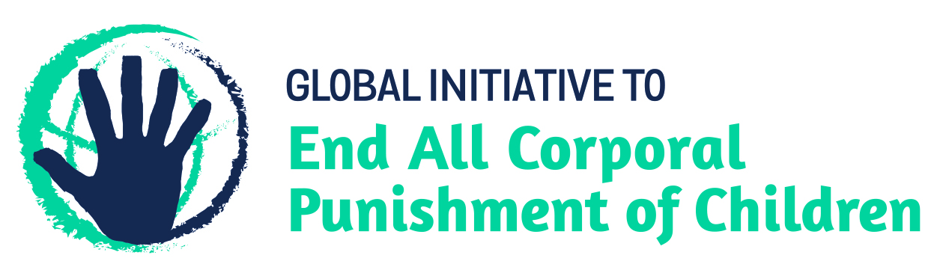
BRIEFING ON MONTENEGRO FOR THE HUMAN RIGHTS COMMITTEE, COUNTRY REPORT TASK FORCE, 128th session (March 2020)
From the Global Initiative to End All Corporal Punishment of Children, January 2020
This briefing provides an update on the legality of corporal punishment of children in Montenegro since its previous examination by the Committee in 2014. We are delighted to inform the Committee that Montenegro has now prohibited corporal punishment in all settings, including the home.
We hope the Committee will, in its concluding observations on Montenegro’s second periodic report, welcome the explicit prohibition of all corporal punishment of children in Montenegro and recommend that all measures be taken to ensure implementation of the prohibition of corporal punishment in all settings, including the home.

1 Prohibition of all corporal punishment of children in Montenegro
  - Corporal punishment is unlawful in all settings, including the home. Amendments to the Family Law 2007 were voted in July 2016 which made substantial changes to the Law. Article 9a was inserted to state: “(1) Child [sic] shall not be subjected to corporal punishment or any other cruel, inhuman or degrading treatment. (2) The prohibition referred to in para 1 above shall pertain to parents, guardians and all other persons taking care of or coming into contact with the child. (3) The persons referred to in para 2 above are obliged to protect the child from any treatment referred to in para 1 above.” The amendments came into effect in August 2016.

Briefing prepared by the Global Initiative to End All Corporal Punishment of Children
www.endcorporalpunishment.org; info@endcorporalpunishment.org

