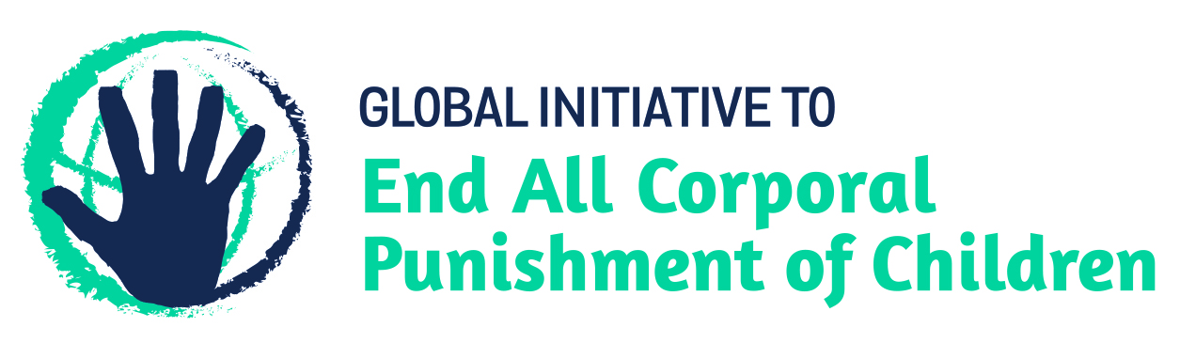
BRIEFING ON LESOTHO FOR THE HUMAN RIGHTS COMMITTEE, COUNTRY REPORT TASK FORCE, 125th session (March 2019)
From the Global Initiative to End All Corporal Punishment of Children, January 2019
This briefing describes the legality of corporal punishment of children in Lesotho. In light of the obligation under international human rights treaties to prohibit all corporal punishment of children, the global commitment to ending violence against children – including corporal punishment – in the context of the 2030 Agenda for Sustainable Development, the recommendations of the UN Secretary General’s Study on Violence against Children, and those made to Lesotho by the Human Rights Committee, the Committee on the Rights of the Child, the African Committee of Experts on the Rights and Welfare of the Child and during the Universal Periodic Review, we hope the Human Rights Committee will:
- raise the issue of corporal punishment of children in its List of Issues Prior to Reporting for Lesotho, in particular asking what steps are being taken to enact legislation explicitly prohibiting all corporal punishment of children, in all settings including the home, and repealing the defence for “justifiable chastisement”; and,
- in its concluding observations on Lesotho’s second state party report, recommend that legislation is immediately drafted and enacted to explicitly prohibit all corporal punishment of children, in all settings including the home, and repeal all legal defences for “justifiable chastisement”.

1 The legality of corporal punishment of children in Lesotho
1.1 Summary: Corporal punishment of children in Lesotho is unlawful in schools and as a sentence for a crime but it is still not prohibited in the home, in alternative care and day care settings, and in penal institutions.
1.2 Home (lawful): Corporal punishment is lawful in the home. In reporting to the African Committee of Experts on the Rights and Welfare of the Child, the Government stated that article 16 of the Children’s Protection and Welfare Act 2011 “prevents all types of corporal punishment”. However, this article does not explicitly prohibit corporal punishment and in fact provides for “justifiable” discipline of children: “(1) A child has a right to be protected from torture or other cruel, inhuman or degrading treatment or punishment, including any cultural practice which degrades or is injurious to the physical, psychological, emotional and mental well-being of the child. (2) A child shall be chastised in accordance with his age, physical, psychological, emotional and mental condition and no discipline is justifiable if by reason of tender age or otherwise the child is incapable of understanding the purpose of the discipline.”
1.3 The Penal Code Act 2010 (in force 2012), intended to codify law already in place in Lesotho, provides a legal defence for the use of corporal punishment of children, stating in article 32 (“Lawful physical force”): “No offence is committed by a person who applies reasonable physical force to another when this is necessary – … (b) for the lawful and reasonable chastisement of children.” The official commentary on the Code states with regard to this article: “Parents and those exercising quasi-parental authority over children are entitled to use moderate force in chastising children under their control. The amount of force used must not be excessive: no parent is allowed to beat a child in a way which causes damage. The chastising of a child must be administered in good faith and proportionate to the misconduct, and not for any reason unconnected with discipline.”
1.4 A Domestic Violence Bill is under discussion but we have no information on proposed provisions. A Children’s Protection and Welfare Act Amendment Bill 2018 is under discussion and would reportedly remove the “justifiable discipline of children” defence from the Act. It does not seem that the Bill would amend the Penal Code Act 2010.
1.5 Alternative care settings (lawful): Corporal punishment is lawful in alternative care settings under the provisions for “justifiable” chastisement in the Children’s Protection and Welfare Act 2011 (art. 16) and for “lawful and reasonable chastisement of children” in the Penal Code Act 2010 (art. 32).
1.6 Day care (lawful): Corporal punishment is lawful in early childhood care and in day care for older children under the provision for “justifiable” chastisement in the Children’s Protection and Welfare Act 2011 (art. 16) and for “lawful and reasonable chastisement of children” in the Penal Code Act 2010 (art. 32).
1.7 Schools (?unlawful): Corporal punishment appears to be unlawful in schools. Article 4 of the Education Act 2010 prohibits cruel punishment: “(4) A learner shall not be subjected to cruel, inhuman and degrading punishment.” While this does not explicitly prohibit corporal punishment, the accompanying Parliamentary Statement of Objects and Reasons of the Education Act 2010 clarifies that one purpose of the law is to prohibit corporal punishment: “5. The Bill abolishes corporal punishment at schools in accordance with section 8 of the Constitution which provides that a person shall not be subjected to torture or to inhuman or degrading punishment.” Article 22 of the Children’s Protection and Welfare Act 2011 states that the state has a duty “to formulate policies which will ensure … (k) that … school discipline is consistent with a child’s rights and dignity” but it does not explicitly prohibit corporal punishment.
1.8 The Government has reported to the African Committee of Experts on the Rights and Welfare of the Child that “the Education Act 2010 and the MOET’s School Regulations abolish corporal punishment in schools”. But we have yet to confirm that the provisions for “lawful and reasonable chastisement of children” in the Penal Code Act 2010 (art. 32) and for “justifiable” chastisement in the Children’s Protection and Welfare Act 2011 (art. 16) may not be used as a legal defence for the use of corporal punishment by teachers. The Teaching Service Regulations 2002 are silent on the issue.
1.9 Penal institutions (lawful): Corporal punishment is lawful in penal institutions. The Prison Proclamation 1957 authorises the imposition of corporal punishment for certain prison disciplinary offences – for a person under 21 “ten strokes of a light cane” (art. 20). Rule 3 of the Lesotho Prison Service Rules 1957 states that the object of detaining a person in a juvenile training centre is to “keep them under discipline”, and rule 31 states that “no officer shall use force unnecessarily when dealing with prisoners”. But Rule 43 allows for the imposition of corporal punishment of males as a punishment for grave offences against prison discipline; rule 44 sets out the rules for its infliction, including the involvement of the medical officer. These laws appear to be still in force.
1.10 According to article 22 of the Children’s Protection and Welfare Act 2011, the state has a duty “to formulate policies which will ensure … (q) that every child alleged as having infringed the penal law is treated in a manner consistent with his sense of dignity or worth and that he is reintegrated into society”, but the Act does not explicitly prohibit corporal punishment in penal institutions and allows for the use of “justifiable” chastisement (art. 16). Furthermore, the Penal Code authorises the use of physical force in the context of “lawful and reasonable chastisement of children” (art. 32).
1.11 Sentence for crime (unlawful): Corporal punishment is unlawful as a sentence for crime. Article 127(5) of the Children’s Protection and Welfare Act 2011 explicitly prohibits corporal punishment and public humiliation as part of diversion and article 161(2) states: “No sentence of corporal punishment or any form of punishment that is cruel, inhumane or degrading may be imposed on a child.” Under article 2(4), the Act prevails over provisions in other legislation “contrary or less protective or less promotive”, which would presumably include the provisions for judicial whipping in the Criminal Procedure and Evidence Act 1981.

2 Recommendations by human rights treaty bodies and during the UPR
2.1 HRC: In 1999, the Human Rights Committee recommended to Lesotho that corporal punishment be abolished in law and in practice in the penal system.
2.2 CRC: The Committee on the Rights of the Child recommended prohibition of all corporal punishment of children in Lesotho in its concluding observations on the state party’s initial report in 2001, and on the second report in 2018.
2.3 ACERWC: In 2015, the African Committee of Experts on the Rights and the Welfare of the Child recommended that Lesotho prohibit corporal punishment in all settings, including the home, and promote positive discipline.
2.4 UPR: At the first cycle Universal Periodic Review of Lesotho in 2010, the Government accepted a recommendations to “abolish child corporal punishment”, stating that it considers it already implemented or in the process of implementation. No recommendations were made specifically on corporal punishment at the second cycle review in 2015, but the Government accepted recommendations to harmonise national laws with international human rights obligations, to protect the rights of children and to implement all the recommendations of the Committee on the Rights of the Child.

Briefing prepared by the Global Initiative to End All Corporal Punishment of Children
www.endcorporalpunishment.org; info@endcorporalpunishment.org

[2015], Initial state party report, page 30
14 March 2018, CRC/C/LSO/Q/2/Add.1, Reply to list of issues, para. 18
[2015], Initial state party report, page 73
Lesotho Legal Information Institute, http://www.lesotholii.org/ls/legislation/act/1964/30, accessed 25 May 2017
8 April 1999, CCPR/C/79/Add.106, concluding observations on initial report, para. 20
21 February 2001, CRC/C/15/Add.147, Concluding observations on initial report, paras. 31, 32, 61 and 62
1 June 2018, CRC/C/LSO/CO/2 Advance version, Concluding observations on second report, paras. 26, 27 and 29
[November 2015], Concluding observations on initial report, para. 27
16 June 2010, A/HRC/15/7, Report of the working group, para. 97(34)
13 April 2015, A/HRC/29/9, Report of the working group, paras. 113(3), 113(6), 113(41) and 113(74)

