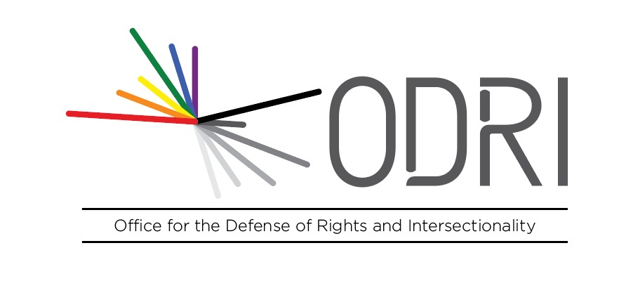
(1580 words)

Contribution to the Human Rights Committee in relation to the adoption of the List of issues prior to the Fifth periodic report of Korea (8 to 26 July, 2019)

Presented by ODRI "Intersectional rights" - Office for the Defense of Rights and Intersectionality

14 May 2019

ODRI "Intersectional rights" - Office for the Defense of Rights and Intersectionality appreciates the opportunity to address the Human Rights Committee in relation to the positive aspects and principal subjects of concern related to the process of List of issues prior to submission of the fifth periodic report of the Republic of Korea.

Introduction and methodology

We sincerely hope that this report will be helpful for the work of the Human Rights Committee in the endeavor of the forthcoming constructive dialogue with the Republic of Korea. ODRI authorizes the OHCHR to upload this submission to the UN Treaty Body Database (https://tbinternet.ohchr.org). If additional information is required, ODRI may assist the Committee with ulterior submissions.

Implementation of the Covenant and its Optional Protocol (article 2 of the Pact)
The Republic of Korea has leading the effective implementation of recommendations of treaty bodies with the creation of a National Mechanism for Reporting and Follow-up (NMRF) under the National Human Rights Policy Council since 2006. Additionally, the Human Rights Committee has adopted views in different cases related to the criminal convictions of a worker for a statement in favour of a strike (communication 518/1992, 3 August 1995), the conviction of a student for reading publicly a statement and the distribution of printed material (communication 574/1994, 3 November 1998), the confiscation of a picture and his criminal sanction (communication 926/2000, 25 April 2000), the criminal conviction for membership in “anti-State organization” (communication 1119/2002, 23 August 2005), the compulsory military service of several conscientious objectors without alternatives of civil nature (communications 1321-1322/2004, 23 January 2007; 1593-1603/2007, 30 April 2010; 1642-1741/2007, 27 April 2011; 1786/2008, 1 February 2013), the deportation of a converted to Christianity to the country of origin (Communication 1908/2009, 15 May 2014), and the Mandatory HIV and drug testing for visa extension (Communication 2273/2013, 10 August 2018). Furthermore, the Human Rights Committee discontinued the consideration of one communication related to the detention conditions and the risks of deportation of several individuals to their country of origin after the parties and the State informed an amiable settlement (communication 2735/2016, 23 June 2017).
Taking into consideration this information, ODRI suggests that the Committee requires the Korean government:
- Provide information related to the current function and the activities of the national mechanism to monitor the implementation of its recommendations and to give human rights impact assessment of legislative, policies and other initiatives or reforms by the Republic of Korea to ensure their compatibility with the Covenant.
- Describe the legal procedures and the mechanisms for authors of individual communications to seek, in law and in practice, the full implementation of Views adopted under the Optional Protocol. Give examples of the particularities of the measures adopted by the State of Korea to provide meaningful participation for the victims of views related to compulsory military service.
- Give examples of case-law where the national courts invoked the Covenant, the Committee’s recommendations and views. Provide specific information of cases related to the articles where the Human Rights Committee declared international responsibility (freedom of expression, freedom of assembly, freedom of thought conscience of religion, prohibition of torture, privacy and equal treatment).
- Describe the activities of awareness and specific training of the Covenant to government officials, judges, prosecutors, lawyers, human rights defenders and stakeholders of civil society organizations.
- Detail the envisaged activities of consultation with civil society organizations for the reporting process of the Fifth periodic report of Korea and the follow-up of the recommendations.

Extraterritorial development aid activities carried out by the Korea International Cooperation Agency (KOICA) in developing countries (article 2 of the Pact)
Since 1991, the State of Korea has conducted aid and development programs in approximately 44 countries, through the governmental department, the Korean International Cooperation Agency (KOICA). After the approbation of the Sustainable Development Goals (SDGs) in September 2015, KOICA has built bilateral partnerships, to help developing and fragile States in different policies including education, health, governance, agriculture and rural development, technology, industry and energy. To ensure SDGs in their projects, KOICA has approved several guidelines to catalyse gender equality and a human rights-based approach to different partnerships to address poverty, climate change, environment, population and global health. As a result, there are several promissory practices of development assistance projects that are positively activities transformation of lives of women with a human rights framework during design, assessment, planning, implementation, monitoring and evaluation of projects.
However, ODRI is concerned that strategies are not taking into considerations of certain identities and vulnerable groups in some cases. For instance, some concerns have appeared in environmental projects in countries where the rights of indigenous peoples and human rights defenders are at risk by governmental beneficiaries and private actors. Moreover, we are worried that in some cases the aid projects do not reach the most affected and vulnerable populations. Furthermore, it is come to the attention of our team that some HIV/AIDS programs had difficulties to protect LGTBI rights in developing countries were sex work and same-sex relations between consenting adults are criminalized. Our team fears that these difficulties and restrictions endanger the completion of 2030 Agenda for Sustainable Development with a human rights-based approach.
To address this situation, we respectfully ask you to solicit the Republic of Korea to:
- Provide examples of the safeguards for the inclusion of human rights impact assessment and gender mainstreaming of international programs on sustainable development.
- Describe human rights accountability mechanisms related to the rights enshrined in the Covenant, with an emphasis on the rights of indigenous peoples, women, persons living with HIV/AIDS, LGTBI and sex workers.
- Describe the proportion of the budget allocated for human rights included in the mechanism for implementation of the Sustainable Development Goals dependent of the Ministry of Foreign Affairs.

Business, human rights and climate change (article 2 and 26 of the Pact)
The Republic of Korea has developed diverse environmental policies to address human rights concerns. For instance, the Korea government is trying to reduce fine dust and dry soil particles related to industrial pollutants by 30 per cent by 2022. Nevertheless, weak energy policies continue to affect negatively the life and personal integrity of women and children, and long-term measures related to mitigation and adaptation to the negative effects of climate change and natural disasters remain inadequate.
Moreover, the Korean Government approved the Third National Action Plan (NAP) for the promotion and protection of human rights. Chapter Eight is titled “A society where everyone works for human rights-friendly corporate operations (Business and Human Rights)”. Despite the several opportunities of this NAP, ODRI is concerned of some discriminatory practices of Korean companies (located in the jurisdiction of Korea and overseas) such as the mandatory HIV/AIDS exams and illegal drugs uses testing for employers as a means of verify corporate values, the lack of equal pay and representation of women in managerial and leadership positions both in public and private companies. ODRI is also terrified by the lack of effectiveness of government-based remedies for human rights abuses committed by States and private companies due to the multiple barriers of victims.
To address this situation, we respectfully ask you to solicit the Republic of Korea to:
- Provide information related to the activities foreseen to address the negatively impacts of climate change and natural disasters in the rights enshrined in the Covenant.
- Provide examples of the activities conducted by the State to guarantee that overseas Korean companies protect human rights in relationship to gender equality and the mandatory tests of HIV/AIDS and illegal drugs uses by employers.
- Provide information related to the environment and human rights assessment of activities conducted by industry activities in Korea and overseas.
- Inform about the results of activities of access to remedy related to the protection of human rights from the negative consequences of business activities.

ODRI “Intersectional rights” - Office for the Defense of Rights and Intersectionality
Central Avenue 1025, Los Álamos de Monterrico
15023, Surco, Lima, Peru
od.intersectionalrights@gmail.com
+51 945 175 190
About ODRI
ODRI “Intersectional rights” - Office for the Defense of Rights and Intersectionality is a Lima-based NGO established in 2017. It is an apolitical and non-confessional. Among its principal goals is the introduction of intersectional approaches and the mainstreaming of the Sustainable Development Goals. To fulfil this goal ODRI currently submits reports assessing the respect of human rights in certain countries to United Nations Treaty Bodies and Special Procedures, and other fora. Moreover, ODRI is involved in the monitoring of criminal complaints in Latin America against individuals suspected of having committed crimes under international law.
To see other contributions presented to the treaty bodies, you can visit our last submissions:
CED. Submission in view of the upcoming consideration of the List of issues in relation to the report submitted by Peru regarding the implementation of the International Convention for the Protection of All Personas from Enforced Disappearances at its 15th Session (05 Nov 2018 - 16 Nov 2018 https://tbinternet.ohchr.org/Treaties/CED/Shared%20Documents/PER/INT_CED_ICO_PER_32073_S.pdf
CEDAW Chile Written submission on Chile Pre-Sessional Working Group 71st session (12 – 16 March 2018) https://tbinternet.ohchr.org/Treaties/CEDAW/Shared%20Documents/CHL/INT_CEDAW_NGO_CHL_29922_E.pdf
CERD Peru Written submission on Peru 95th Session (23 April–11 May 2018)
https://tbinternet.ohchr.org/Treaties/CERD/Shared%20Documents/PER/INT_CERD_NGO_PER_30860_E.pdf

This report was made by Diego Ocampo, Marisa Paredes and Andrés Sifuentes.

