Submission to the 126th Session
13 May 2019
Geneva, Switzerland

INDIA

HUMAN RIGHTS COMMITTEE

Submission by:

ADF International
Chemin du Petit-Saconnex 28
1209 Geneva, Switzerland

Web: www.ADFinternational.org
Email: un@ADFinternational.org

ECOSOC Special Consultative Status (2010)

Introduction
- ADF International is a faith-based legal advocacy organization that protects fundamental freedoms and promotes the inherent dignity of all people. As well as having ECOSOC consultative status with the United Nations (registered name ‘Alliance Defending Freedom’), ADF International has accreditation with the European Commission and Parliament, and the Organization of American States. ADF International is also a participant in the FRA Fundamental Rights Platform.
- ADF International welcomes the opportunity to provide the below information to the United Nations Human Rights Committee in view of the adoption of the list of issues for India at its 126th session in July 2019.
- This submission addresses the situation of freedom of religion or belief in India, notably by detailing episodes of violence and harassment towards Christians and other religious minorities across the country, and highlighting the failure of law enforcement and judicial authorities to adequately investigate such cases and hold perpetrators accountable. It also examines the lack of appropriate rehabilitation and compensation for victims of wrongful or malicious prosecution and incarceration. Furthermore, the submission reviews the discriminatory legal and societal framework to which they are subjected both at the state and province levels. Finally, it suggests questions pertaining to India’s implementation of relevant provisions of the International Covenant on Civil and Political Rights (ICCPR), and offers recommendations in anticipation of the formal review.
- Background
- India has the world’s largest population of Hindus, the third largest Muslim population and a Christian population of over 25 million. The country is also home to numerous Sikhs, Buddhists, Jains, Zoroastrians, Jews, and Baha’is and people belonging to other animist traditions. Its Constitution guarantees under Article 19 that every person in India shall have the freedom of speech, expression and association, and under Article 25, the equal right to freedom of conscience and the right freely to profess, practise and propagate religion.
- Religious minorities in India have experienced an increased rise in violence and hostility, with a sharp increase in reported incidents over the period from 2014 to 2018. According to data presented before the Parliament by the Ministry of Home Affairs, communal incidents increased by 28 percent over three years with 822 incidents recorded in 2017, leading to as many as 111 casualties and 2,384 people injured.
- Violence against the Christian minority community in India has also escalated in the past few years, with faith-based human rights organizations recording over 800 incidents in the past four years. Out of 29 states, at least 16 regularly witness attacks on Christians: Chhattisgarh tops the list, followed by Tamil Nadu, Uttar Pradesh, Madhya Pradesh and Maharashtra. Christians are also particularly at risk of violence and harassment in the states of Bihar, Delhi, Haryana, Himachal Pradesh, Jharkhand, Karnataka, Punjab, Telangana, Uttarakhand and West Benga. In addition to violence, social exclusion is also commonly used as a tactic to victimize minorities, notably by denying them basic human rights and services such as access to water and electricity, as well as employment, thereby increasing their vulnerability.
- In the first three months of 2019, human rights groups reported over 80 incidents of violence against Christians across India. Many of these involved clear, systemic violations of the rights enshrined under the ICCPR.
- Liberty and security of person, right to equality before courts and tribunals and to fair trial, (Articles 9 and 14)
- Christians have repeatedly faced attacks by government authorities and non-state actors alike. The violence against religious minorities is further compounded by the failure of the police to take all necessary preventive and protective measures, and the shoddy investigation and prosecution of individuals who actively engaged in mob violence.
- As a result, in July 2017 the Supreme Court of India came down heavily against the police force of the central Indian state of Madhya Pradesh for failing to produce relevant evidence before the trial court, highlighting the ignored role of the accused in a case of mob violence against members of a minority community.
- A report prepared by Amnesty International India on the violence in Muzaffarnagar District of the northern Indian state of Uttar Pradesh–which witnessed a wave of violence against the minority Muslim community in 2013, resulting in over 60 deaths and 50,000 internally displaced persons–documents the complete failure of the police to protect the victims and to take necessary action against those responsible. Media reports also suggested that the prosecution of the accused was also undertaken in a very casual manner. For instance, as of March 2016, of the 1,475 accused arrested in cases of murder, rape, arson and dacoity in connection with the 2013 Muzaffarnagar riots, only 37 are behind bars. Thirty-nine of the accused have been acquitted while the others have been released on bail.
- Furthermore, instead of taking firm action on the basis of the observations of the Supreme Court to rectify such failures, in March 2018 the Uttar Pradesh government initiated the process of withdrawing 131 cases involving violent acts allegedly committed by Hindu extremists during the riots in the cities of Muzaffarnagar and Shamli, including 13 murder and 11 attempted murder cases.
- Further highlighting the grave abuse of power by the police and the protection it often affords to mobs, among the over 250 documented incidents of violence against Christians, a criminal complaint was registered only in 25 cases.
- In a 2009 judgment concerning the communal violence in Kandhamal, which caused the death of over 100 people and the internal displacement of around 50,000 persons in the eastern Indian state of Odisha (earlier known as Orissa), the Supreme Court observed that:
“The affidavit filed on behalf of the State on 01.03.2013 discloses that out of 827 registered cases, 512 cases resulted in filing of charge-sheets while in 315 cases final reports were submitted. In other words, in 315 cases either no offence was found to have been made out or the offenders could not be detected. Such large proportion is quite disturbing. The State could do well in looking into all these 315 cases and see that the offenders are brought to book. Similarly, out of 362 trials which stand completed only 78 have resulted in conviction, which again is a matter of concern. The concerned authorities must see to it that the matters are taken up wherever acquittals were not justified on facts.”
- India, despite having ratified the ICCPR, has to date failed to provide any domestic legislation allowing for rehabilitation and compensation of victims of wrongful or malicious prosecution and incarceration. While some courts have occasionally granted compensation to such victims in appropriate cases, these remain few and far between.
- Right to privacy, freedom of thought, conscience and religion, freedom of opinion and expression, right to peaceful assembly, right to equality and non-discrimination, rights of minorities (Articles 17, 18, 19, 21, 26, 27)
- Due to growing hostility and violence, Christians in India have become increasingly vulnerable even in their home and churches. Furthermore, human rights groups have frequently reported that Christians are refused the right to bury their dead, as well as to associate with other Christians and assemble peacefully.
- In 2018 alone, close to 100 churches (55 in Uttar Pradesh, 25 in Uttarakhand, and 19 in Tamil Nadu) were closed after Hindu fundamentalists raided them or filed complaints with the police. Churches have also filed petitions before various fora to highlight the illegal attempts being made to stop them from conducting worship in the area, citing ‘law and order’ problems.
- In the central Indian state of Chhattisgarh, some villages banned the entry of and proselytization both in private and in public by non-Hindu missionaries, including in particular Christians. According to media reports, up to 50 villages had imposed the ban before the courts reversed the orders of the respective village councils.
- Over the past year, Christians have been prevented from, and even arrested for participating in carol singing. In the state of Tamil Nadu, in the southern part of India, a church group was forced to seek a court order to provide police protection to the homes of their members in order for them to safely sing carols. In another incident, 30 priests and seminarians singing carols in a village near Satna in central Indian state of Madhya Pradesh were detained by police after Bajrang Dal activists accused them of trying to forcibly convert the villagers. One of the priests was eventually arrested under the state’s draconian anti-conversion law.
- In the central state of Madhya Pradesh, Catholic institutes were threatened by local student bodies, allegedly under the influence of the radical Hindu groups, to conduct prayers for and install a painting depicting Bharat Mata (Mother India).
- In the western Indian state of Goa, over 150 crosses and 40 graveyards were desecrated in without the police being able to identify and arrest the culprits. Civil society groups ascribed the increased hostility towards the Christians to calls for violence against minority communities by radical Hindu groups.
Anti-conversion laws
- In spite of the protections afforded by the Constitution of India, the State has passed discriminatory laws and polices that violate the fundamental human rights to equality and non-discrimination and the freedom to practice, profess and propagate one’s faith.
- The Freedom of Religion Acts, more commonly known as “anti-conversion laws”, were previously enacted at the state or province level in Odisha (previously known as Orissa) in 1967, Madhya Pradesh (1968), Arunachal Pradesh (1978), Chhattisgarh (2000), Gujarat (2003), Himachal Pradesh (2006), Jharkhand (2017), Uttarakhand (2018). These laws have undermined the guarantees under the Constitution of India and various international human rights standards and treaties to which India is signatory, to the right to equality, life and freedom of religion and association. In particular, the anti-conversion laws enacted in Uttarakhand, Jharkhand and Gujarat require those “performing” or participating in any “ceremony” for conversion to seek prior permission. These requirements leave converts vulnerable and subject to violence and hostility.
- The former UN Special Rapporteur on Freedom of Religion or Belief, Asma Jahangir, noted in a report after her mission to India that “even in the Indian states which have adopted laws on religious conversion, there seem to be only few – if any – convictions for conversion using force, inducement or fraudulent means. In Orissa, for example, not a single infringement over the past ten years of the Orissa Freedom of Religion Act 1967 could be cited or adduced by district officials and senior officials in the State Secretariat… However, such laws or even draft legislation have had adverse consequences for religious minorities and have fostered mob violence against them.” The report further stated that “there is a risk that Freedom of Religion Acts may become a tool in the hands of those who wish to use religion for vested interests or to persecute individuals on the grounds of their religion or belief. While persecution, violence or discrimination based on religion or belief need to be sanctioned by law, the Special Rapporteur would like to caution against excessive or vague legislation on religious issues which could create tensions and problems instead of solving them.”
- Indeed, these laws are frequently misused to falsely accuse Christians and other religious minorities of forceful conversion and violate the freedom to practice and propagate one’s faith. For instance, on 21 May 2017, eight Christians, including two women, were arrested on false allegations of forceful religious conversion of 60 children in the district of Ratlam, in Madhya Pradesh. The children, who declared themselves Christians, reported that they were going to a Vacation Bible School in Nagur, Maharashtra with their parents’ consent. Similarly, on 21 May 2017, two Christian pastors were arrested on false allegations of forceful religious conversion of 11 children in the district of Indore, in Madhya Pradesh. The children were kept in police custody until midnight. The case against the pastors is still pending before the judicial authorities.
- These laws violate the freedom to change one’s religion, enshrined inter alia in Article 18 of the ICCPR. Indeed, as confirmed by the Human Rights Committee in its General Comment No. 22, the right to freedom of thought, conscience and religion “encompasses freedom of thought on all matters, personal conviction and the commitment to religion or belief”, and includes the ‘freedom to have or to adopt a religion or belief of [one’s] choice,” the right to “replace one’s current religion or belief with another or adopt atheistic views, as well as the right to retain one’s religion or belief.” This same General Comment declares that even if “a religion is recognized as a state religion or that it is established as official or traditional or that its followers comprise the majority of the population,” that this fact “shall not result in any impairment of the enjoyment of any of the rights under the Covenant.”
- Anti-conversion laws also violate the right to propagate religion, which the Human Rights Committee has held to be part of the right to manifest religion. The former UN Special Rapporteur on freedom of religion or belief, Prof. Heiner Bielefeldt, noted that “any generalized State limitation (e.g. by law) conceived to protect ‘others’’ freedom of religion and belief by limiting the rights of others to conduct missionary activities should be avoided”. Similarly, the current UN Special Rapporteur on freedom of religion or belief has argued that “such laws often violate both forum internum and forum externum aspects of the right to freedom of religion or belief.”
Caste-based discrimination
- The Constitution of India also recognizes Dalits as Scheduled Castes by means of Constitution (Scheduled Castes) Order of 1950, which designates the different caste groups to receive special government benefits, including jobs, housing, and educational opportunities. According to the abovementioned order, these groups also receive special protection under hate crime laws established in the Scheduled Castes and the Scheduled Tribes (Prevention of Atrocities) Act of 1989.
- Regrettably, the Indian government grants complete protection and freedom only to Scheduled Castes who are Hindu, Sikh, or Buddhist. Indeed, paragraph 3 of the 1950 Order states that “no person who professes a religion different from the Hindu, the Sikh or the Buddhist religion shall be deemed to be a member of a Scheduled Caste.”
- The denial of Scheduled Caste status has severely affected the millions of Christian and Muslim Dalits who suffer extreme poverty. A 2008 report by the National Commission for Minorities explains that Christian and Muslim Dalits are treated as “socially inferior” and points to the growing evidence of their “social economic and educational backwardness.” Many are in fact poor and illiterate, forced to work as manual scavengers, removers of human waste and dead animals, and street sweepers. Given the stark findings, the report concludes “that there is no compelling evidence to justify denying SC status to Dalit Muslims and Christians.”
- In response to a request for an opinion made by the Supreme Court of India following a petition challenging the constitutionality of the 1950 Presidential order, that is pending before it since 2004, the Government mandated the National Commission for Religious and Linguistic Minorities (NCRLM) to undertake a study and make recommendations on the issue. In May 2007, the NCRLM recommended that Scheduled Caste status should no longer be linked to religious identity. Similarly, the National Commission for Scheduled Castes (NCSC) and the National Commission for Minorities (NCM) have also issued recommendations to the same effect.
- The content of the NCRLM recommendations have been echoed inter alia by the Special Rapporteur on FORB and the UN Committee on the Elimination of Racial Discrimination (CERD), thereby creating an overwhelmingly strong mandate. Yet, in spite of these finding, the state continues to deny equal protection to Dalit Christian and Muslim communities and has failed to file any reply before the Supreme Court with regard to the abovementioned petition.
- Conclusions and Recommendations
Recommended questions
- In the light of the aforementioned, ADF International wishes to suggest the following questions be included by the Human Rights Committee in the list of issues to be transmitted to the Government of India:
- Please provide information on the measures taken to safeguard the right to freedom of religion or belief, including in particular the right to freely manifest one’s religion or belief, either alone or in community with others and in public or private.
- Please provide information on the safeguards put in place to prevent extremist groups from harassing, intimidating or persecuting Christians and other religious minorities.
- Please explain what efforts the State party has made to ensure that incidents of targeted violence against religious minorities are effectively investigated by the police and prosecuted by judicial authorities.
- Please explain how religious minorities’ rights to freedom of religion and Belief are protected under the various anti-conversion laws that are enacted across India.
- Please explain how the Constitution (Scheduled Caste) Order 1950 is compatible with Article 18 of the Covenant.
- Please provide information on the legislative, regulatory and other measures taken to ensure that marginalized groups – including in particular Dalit Christians and Muslims, and other religious minorities – benefit from programs aimed at guaranteeing the full enjoyment by them of all human rights.
Suggested recommendations
- ADF International also urges the Human Rights Committee to include the following recommendations in its Concluding Observations on India:
- Protect the safety and security of Christians and other religious minorities by ensuring that violations are effectively identified, and appropriate and timely action is taken by law enforcement officials and the judiciary;
- Enact legislation protecting the right to rehabilitation and compensation of victims of wrongful or malicious prosecution and incarceration;
- Provide human rights training to police and judicial officials on the rights of religious minorities and other vulnerable communities.
- Actively identify and repeal various discriminatory laws and policies which curtail the freedom of conscience and the freedom of religion of belief, including in particular the Freedom of Religion Acts and the 1950 Presidential Order.
- Take steps to strengthen human rights monitoring mechanisms, including the National Commission for Minorities and the National Human Rights Commission.
- Urgently implement the recommendation of the National Commission for Religious and Linguistic Minorities and other bodies, to no longer use religion as a criterion for determining eligibility for Scheduled Caste membership.
- Repeal anti-conversion legislation currently in force in the states of Odisha, Madhya Pradesh, Chhattisgarh, Gujarat, Himachal Pradesh, Jharkhand and Uttarakhand.

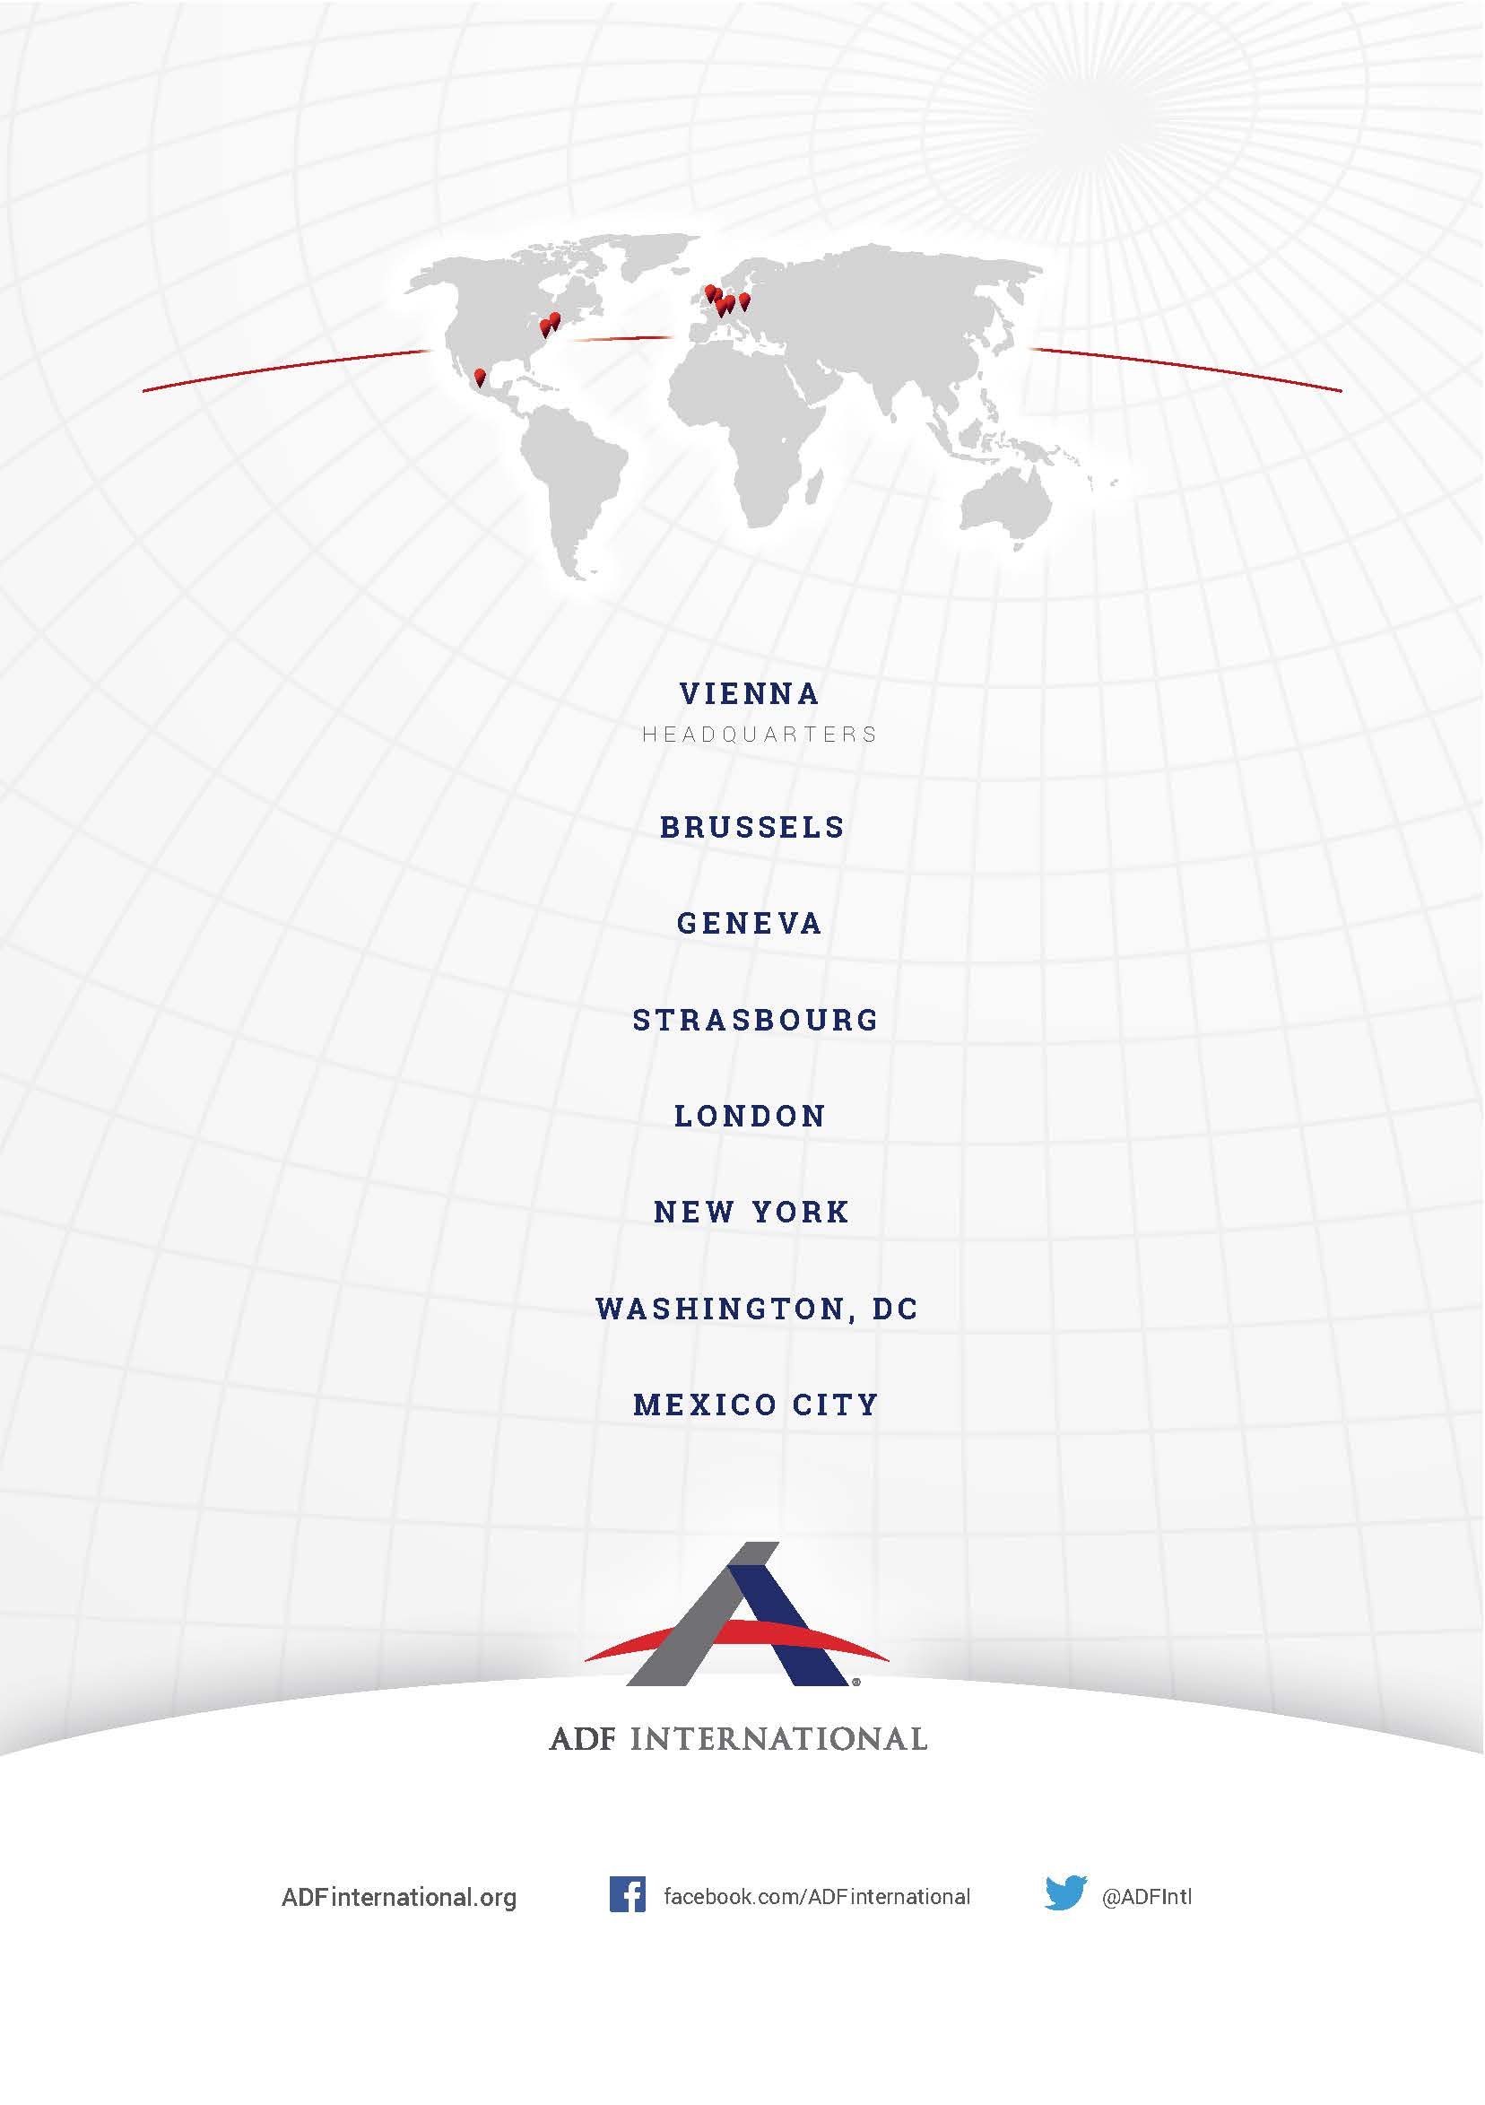
© 2019

Constitution of India, part III, art. 19 and 25.
Ministry of Home Affairs of India, Response to Lok Sabha Unstarred Question No. 590 (Feb. 6 2018), http://164.100.47.190/loksabhaquestions/annex/14/AU590.pdf.
Speak Out Against Hate, Mapping hostility and discrimination against Christians in India, www.speakoutagainsthate.org.
Id.
Communal riots 2013: Supreme Court raps Madhya Pradesh police for non-examination of VCD, Firstpost (July 17, 2017), https://www.firstpost.com/india/communal-riots-2013-supreme-court-raps-madhya-pradesh-police-for-non-examination-of-vcd-3824077.html.
Losing Faith: the Muzaffarnagar gang-rape survivors’ struggle for justice, Amnesty International India (Feb. 19, 2017), https://drive.google.com/file/d/13vMKS4zJwGcU-npOsoziSMTNfiVcAZZD/view.
Manish Sahu, 1,475 arrests in Muzaffarnagar riots cases, only 37 in jail, The Indian Express (Mar. 16, 2016) http://indianexpress.com/article/cities/lucknow/muzaffarnagar-riots-cases-37-in-jail/.
Manish Sahu, Yogi Adityanath government initiates process on withdrawal of 131 riots cases, The Indian Express (Mar. 22, 2018), http://indianexpress.com/article/india/yogi-adityanath-govt-initiates-process-on-withdrawal-of-131-riots-cases-muzaffarnagar-shamli-5106475/.
Data By ADF India.
Supreme Court of India, Writ Petition (Civil) No. 76/2009 (Aug. 2, 2016), http://supremecourtofindia.nic.in/FileServer/2016-08-03_1470223736.pdf.
Data by ADF India.
Nirmala Carvalho, Chhattisgarh High Court lifts ban on non-Hindu missionary activities, Asia News (Oct. 19, 2015), http://www.asianews.it/news-en/Chhattisgarh-High-Court-lifts-ban-on-non-Hindu-missionary-activities-35622.html.
https://www.thehindu.com/news/national/other-states/police-detain-carol-singing-group-in-madhya-pradeshs-satna/article21716250.ece
Police detain carol-singing group in Madhya Pradesh’s Satna, The Hindu (Dec. 16, 2017), http://indianexpress.com/article/india/madhya-pradesh-catholic-school-outfit-moves-hc-seeking-protection-from-abvp-5024889/.
Irfan Engineer, Fact Finding Report on the desecrations of Holy Crosses and Graves in South Goa: a Definite Pattern, The Milli Gazette (Aug. 4, 2017), http://www.milligazette.com/news/15792-fact-finding-report-on-the-desecrations-of-holy-crosses-and-graves-in-south-goa.
UN Human Rights Council ‘Report of the Special Rapporteur on Freedom of Religion or Belief’ (2009) UN Doc A/HRC/10/8/Add.3.
First Information Report (FIR) No. 0091 at Ratlam Police Station (May 23, 2017).
FIR No. 0074 at Police Gwaltoli, Indore, (May 22, 2017).
Mridula Chari, Forced detention: How Hindutva groups in MP targeted children heading to Mumbai for Bible study, Scroll.in (Nov. 9, 2017), https://scroll.in/article/857187/forced-separation-how-hindutva-groups-in-mp-targetted-children-heading-to-mumbai-for-bible-study.
UN Human Rights Committee ‘General Comment 22’ in ‘Note by the Secretariat, Compilation of General Comments and General Recommendations adopted by Human Rights Treaty Bodies’ (1993) UN Doc CCPR/C/21/Rev.1/Add.4.
UN Human Rights Council ‘Report of the Special Rapporteur on Freedom of Religion or Belief’ (2019) UN Doc A/HRC/40/58.
Constitution (Scheduled Castes) Order (Aug. 10, 1950), http://socialjustice.nic.in/writereaddata/UploadFile/CONSTITUTION%20(SC)%20ORDER%201950%20dated%2010081950.pdf.
National Commission for Minorities of India, Dalits in the Muslim and Christian Communities, A Status Report on Current Social Scientific Knowledge (Jan. 17, 2007), http://ncm.nic.in/pdf/report%20dalit%20%20reservation.pdf.
Ministry of Minority Affairs, Report of the National Commission for Religious and Linguistic Minorities (May 10, 2007), http://www.minorityaffairs.gov.in/sites/default/files/volume-1.pdf.

