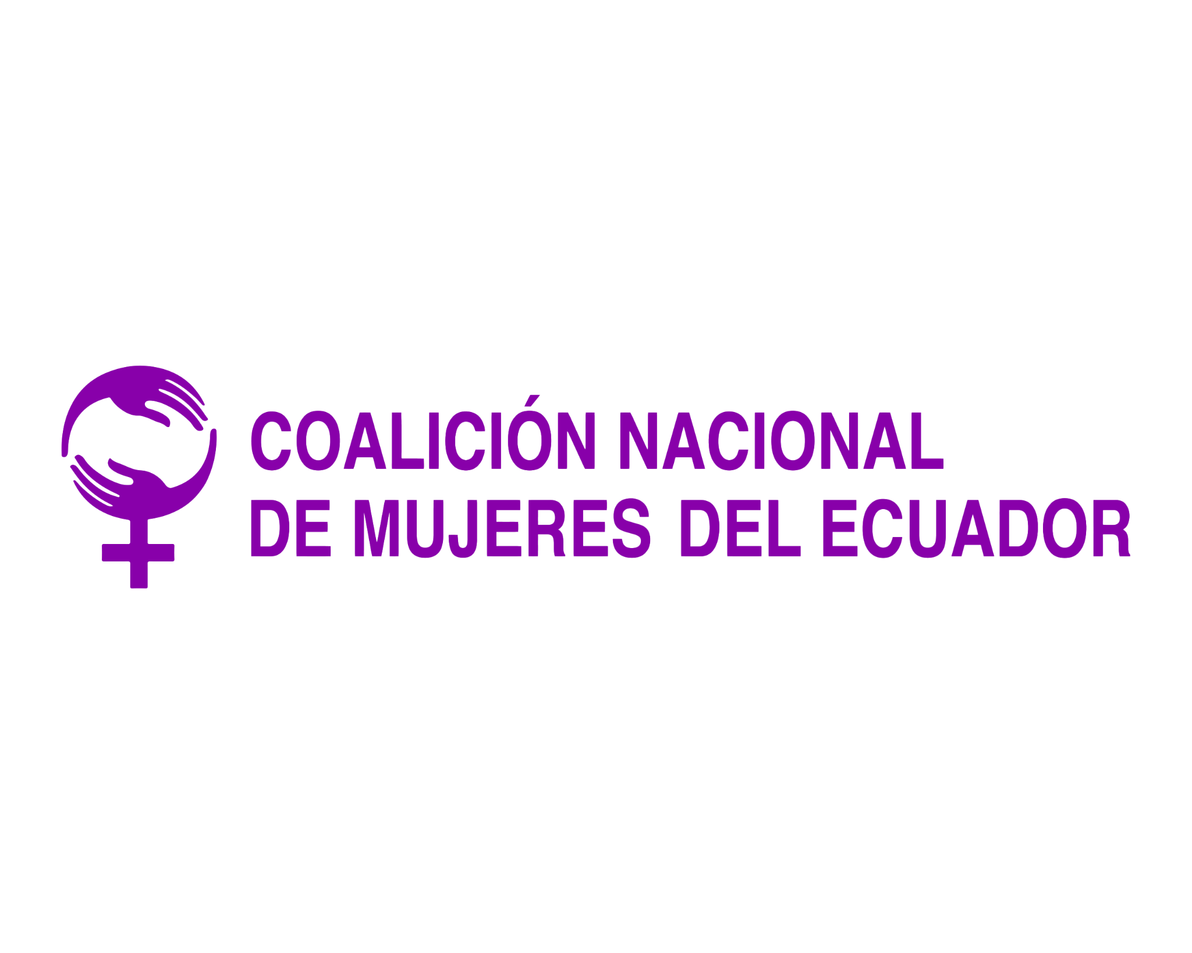


Gabriella Habtom
Secretary of the Human Rights Committee
Human Rights Committee Secretariat
8-14 Avenue de la Paix
CH 1211 Geneva 10
Switzerland
Via Email: ghabtom@ohchr.org; crosniansky@ohchr.org; ccpr@ohchr.or

21 May 2021

Information on the List of Issues Prior to Reporting for Ecuador for Consideration by the Human Rights Committee at its 132nd Session (28 June - 23 July 2021)

Introduction

- We present the following submission in advance of the 132nd session of the Human Rights Committee (‘the Committee’), taking place between 28 June - 23 July 2021, for consideration of the List of Issues Prior to Reporting for Ecuador. Equality Now is writing to express our concern about sexual violence laws and procedures that deny justice to survivors in Ecuador. In this submission, we recommend questions to be asked to Ecuador by the Committee and we respectively offer suggestions on the legal and procedural changes necessary to ensure perpetrators of sexual violence are brought to justice, that survivors are able to access justice, and that gender discriminatory provisions in Ecuador’s laws are abolished.

Information about the authors of the submission

- Equality Now is an international human rights NGO with ECOSOC status with the mission to achieve legal and systemic change that addresses violence and discrimination against all women and girls around the world. Founded in 1992, Equality Now is a global organization with partners and members in every region. Ending sexual violence, ending sex trafficking, ending harmful practices and achieving legal equality are the main areas of Equality Now’s work.

- The National Coalition of Women of Ecuador (2014) is integrated by fourteen national and territorial organizations. They work in advocacy on legislation and public policies for equality, including the preparation of alternative reports to the Human Rights Committees and the strengthening of capacities of the leaders of feminist and women's organizations.

- The legal provisions and practices detailed in this submission highlight the failure of the State to comply with its obligations under Article 2 (non-discrimination), Article 3 (equality for men and women), Article 7 (prohibition of inhuman treatment) and Article 26 (equality before the law) of the International Covenant on Civil and Political Rights (ICCPR). Specifically, this submission details Ecuador’s failure with regard to laws related to rape and other forms of sexual violence, and procedures and practices which effectively deny survivors of sexual violence access to justice.

- We reiterate the Concluding Observations on the sixth periodic report of Ecuador and underline, in particular, the recommendations urging the government of Ecuador to:

- redouble its efforts to prevent and combat all acts of violence against women and to investigate, prosecute and ensure appropriate punishment for persons responsible for such acts.
- redouble its efforts to strengthen the capacities of justice officials throughout the country in order to ensure that complaints are followed up and that all victims obtain redress and appropriate protection measures without delay.
- further ensure that the implementation of the National Plan for the Elimination of Gender Violence against Children, Adolescents and Women is constantly monitored with a view to attaining specific benchmarks.

Legal Provisions enabling impunity for perpetrators of sexual violence

The definition of rape

- Contrary to international human rights law, Ecuador does not base the crime of rape on the lack of free and voluntary consent of the victim. Rather, Ecuador requires that violence, threats or intimidation be used, unless the victim is “incapacitated” or below the age of 14 years.

- Under international human rights standards, including those from the Committee on the Elimination of Discrimination against Women (CEDAW), the Mechanism to Follow Up on the Implementation of the Convention on the Prevention, Punishment and Eradication of Violence against Women (MESECVI), the Declaration on Violence Against Women, Girls and Adolescents and their Sexual and Reproductive Rights, UN Women, and the Council of Europe Convention on Preventing and Combating Violence against Women and Domestic Violence (Istanbul Convention), and including the jurisprudence of the Committee on the Elimination of Discrimination against Women (CEDAW), the International Criminal Court (ICC), the Inter-American Court, the International Criminal Tribunal for Rwanda (ICTR), and the International Criminal Tribunal for the Former Yugoslavia (ICTY), the victim’s lack of consent, and not the presence of force or violence, should be the central element of the crime of rape.

- In the recent report of the UN Special Rapporteur on Violence against Women, “Rape as a grave, systematic and widespread human rights violation, a crime and a manifestation of gender-based violence against women and girls, and its prevention,” the Special Rapporteur recommends that the definition of rape covers all persons, all acts of penetration of a sexual nature, and explicitly includes lack of consent at its centre.

- In addition to basing the definiton of rape on the victim’s lack of consent, international human rights standards call for consent to be assessed in the context of the surrounding circumstances and the definition/crime should include a wide range of coercive circumstances where consent cannot be considered to have been given freely or voluntarily. The UN Women Guidelines state that laws should provide a broad range of circumstances in which consent is immaterial, such as sexual assault by an individual in a position of authority such as in a correctional facility, a religious or school setting or by individuals in certain professional relationships to the survivor such as an ongoing psychotherapist-patient relationship. Additionally, the UN Women Guidelines recommend that laws provide for a broad range of coercive circumstances around consent, including in situations that involve intimidation, fraud or where the perpetrator creates fear of violence, applies duress, psychological oppression, or abuses his power.

- Further, the UN Special Rapporteur on Violence against Women noted in her report on her visit to Ecuador that “the current definition of rape in article 171 of the Criminal Code is not in line with international standards. The unacceptable tolerance of rape, including within the criminal justice system, has resulted in low reporting rates, and even when reported, in low prosecution rates and impunity for perpetrators.” The Special Rapporteur explicitly urged “the legislative authorities in the country to take steps to amend the current definition of rape to ensure that it is based on the absence of consent, and that it is in line with international standards, as provided for by the CEDAW Committee's General Recommendation No. 35.”

- As indicated by the Special Rapporteur on Violence against Women and borne out by Equality Now’s experience, the current definition of rape contributes to the low prosecution rates and impunity for perpetrators. The lack of a consent-based definition of rape leaves many coerced sexual acts, especially those that leave no physical trace, unpunished. Such a defintion also means that the prosecution of rape is overwhelmingly limited to situations where the victim has physical evidence of injuries or force. To align with international human rights standards and esnure the rights of survivors are protected, the law should underscore that rape does not require evidence of additional force as rape itself is a violent act and that additional violence should be considered an aggravating factor.

Estupro

- Another provision of the law which impedes access to justice for survivors and specifically under-protects and discriminates against adolescent survivors is the law of estupro. The estupro provision applies to sexual intercourse with adolescents. Under this provision, where an adult uses deceit to have sexual intercourse with a person aged 14, 15, 16, or 17 years, the offense is punishable with imprisonment for only 1 to 3 years; whereas a conviction of rape is punishable by imprisonment for 19 to 22 years, unless an enhancement provision applies to increase the term of imprisonment to 22 to 26 years. Although this means that rape of adolescents can be prosecuted, albeit with less accountability, where no additional violence can be proved and therefore the crime of rape cannot be prosecuted, this provision tends to weaken the overall statutory scheme against sexual violence. This is for two reasons: a) because [judges and/or prosecutors] not infrequently reduce what should be rape charges to estupro because they buy into rape myths and tend to blame the adolescent girls for being “temptresses” and therefore effectively to blame for the violence perpetrated against them; and b) the law plays a normative role in suggesting a notion of a hierarchy of rape and the harms caused by it and the law itself and the way it is implemented reinforce the myth of adolescent girls as “temptresses” and therefore effectively to blame for the violence perpetrated against them.

- In 2005, the Ecuadorian Government amended the earlier version of estupro, which provided for a lesser penalty for adults who rape adolescents by means of “seduction or deceit,” by removing “by means of seduction.” While this was a positive, commendable development, maintaining a lesser penalty for adults who rape adolescents by means of “deceit” still leaves significant gaps in the law enabling impunity for perpetrators.

- The estupro law allows adults who rape adolescents to avoid the full consequence of their crime. This law ignores the unequal power dynamics between adolescents and adults, and renders adolescents potentially vulnerable to exploitation.

Suggested Questions and Recommendations for State Party’s List of Issues Prior to Reporting
- We respectfully urge the Committee to raise the following questions with the government of Ecuador:
- What plans does the Government have to eliminate all requirements to show force, threat of force, or intimidation for all cases of rape and to ensure that the definition of rape covers all forms of sexual acts committed without the victim’s voluntary, genuine, and willing consent, and in a wide range of coercive circumstances?

- What is the Government doing to eliminate estupro or similar provisions that treat adolescents differently? And will the Government ensure that the definition of rape is amended prior to or in conjunction with the elimination of estupro to ensure there are no gaps in the law and that those who commit rape, including of adolescents, will always be held accountable?

- What steps will the Government take to ensure that sentences for sexual violence crimes (including rape, sexual assault, marital rape, incest, rape of a minor) are commensurate with the gravity of the acts involved?

CCPR/C/ECU/CO/6 available at https://tbinternet.ohchr.org/_layouts/15/treatybodyexternal/Download.aspx?symbolno=CCPR%2fC%2fECU%2fCO%2f6&Lang=en
See Article 171 of Title IV, Section Four of the Codigo Organico Integral Penal de Ecuador.
CEDAW Committee, General recommendation No. 35.
Second Hemispheric Report on the Implementation of the Belém do Pará Convention (Apr. 2012).
OEA/Ser.L/11.710 MESECVI/CEVI/DEC.4/14 (19 Sept. 2014).
UN Women, ‘Handbook for legislation on violence against women’, 2012, p. 24.
Article 36(2) of the Council of Europe Convention on preventing and combating violence against women and domestic violence (Istanbul Convention).
CEDAW Committee, Vertido v Philippines, Merits, Communication No. 18/2008, UN Doc CEDAW/C/46/D/18/2008 (2010); R.P.B. v Philippines, Communication No. 34/2011, UN Doc. CEDAW/C/57/D/34/2011 (2014).
ICC Rules of Procedure and Evidence; Articles 7(2) and 8(2) of the ICC Elements of the Offences; Article 7 (1) (g)-1, Elements of Crimes, International Criminal Court, 2011; Katanga ICC-01/04-01/07, Decision on the Confirmation of Charges, 30 September 2008, § 440; Bemba ICC-01/05-01/08-3343, 21 March 2016, §§ 105-106.
Case of Fernandez Ortega et al v Mexico, Judgment of May 15 2011, Interpretation of judgment on preliminary objection, merits, reparations and costs.
The Prosecutor v. Jean-Paul Akayesu, ICTR-96-4-T, Trial Chamber 1, 2 September 1998 7 Prosecutor v Kunarac, Kovac and Vukovic (No. IT-96-23& IT-96-23/1-A).
Prosecutor v Kunarac, Kovac and Vukovic (No. IT-96-23& IT-96-23/1-A), ICTY, 12 June 2002.
Report of the United Nations Special Rapporteur on violence against women, its causes and consequences, Dubravka Šimonović, “Rape as a grave, systematic and widespread human rights violation, a crime and a manifestation of gender-based violence against women and girls, and its prevention”, A/HRC/47/26, April 2021, para 112.
UN Women, Legislation should define consent as unequivocal and voluntary agreement, UN Women, Virtual Knowledge Centre to End Violence against Women and Girls, 2011, available at https://www.endvawnow.org/en/articles/469-consent.html.
Report of the United Nations Special Rapporteur on violence against women, its causes and consequences, Dubravka Šimonović, “Visit to Ecuador”, A/HRC/44/52/Add.2, May 2020, para 24.
Report of the United Nations Special Rapporteur on violence against women, its causes and consequences, Dubravka Šimonović, “Visit to Ecuador”, A/HRC/44/52/Add.2, May 2020, para 96(a).
See Article 167, Title IV, Section Four of the Codigo Organico Integral Penal de Ecuador.
See Article 171, Title IV, Section Four of the Codigo Organico Integral Penal de Ecuador.
Inter-American Court of Human Rights, Judgment in the Case of Guzmán Albarracín y otras vs. Ecuador, 24 June 2020, https://www.corteidh.or.cr/docs/casos/articulos/seriec_405_esp.pdf

