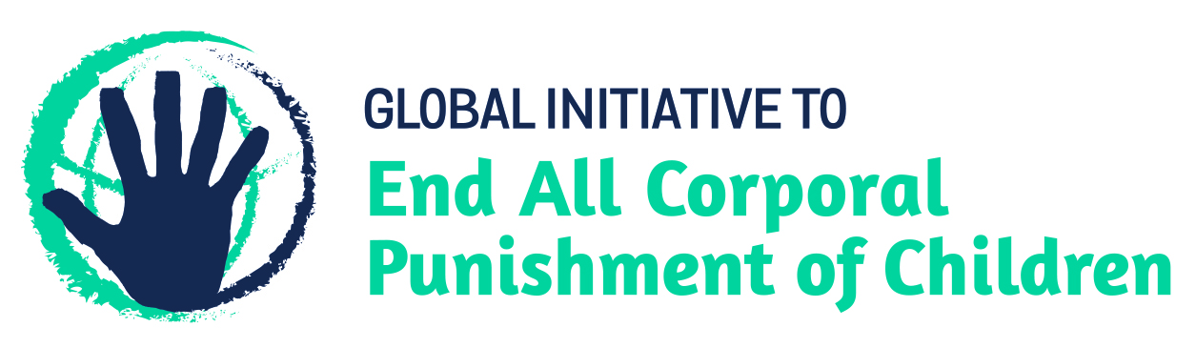
BRIEFING ON CHILE FOR THE HUMAN RIGHTS COMMITTEE, COUNTRY REPORT TASK FORCE, 126th session (July 2019)
From the Global Initiative to End All Corporal Punishment of Children, May 2019
This briefing describes the legality of corporal punishment of children in Chile. In light of the obligation under international human rights treaties to prohibit all corporal punishment of children, the global commitment to ending violence against children – including corporal punishment – in the context of the 2030 Agenda for Sustainable Development, the recommendations of the UN Secretary General’s Study on Violence against Children, and those made to Chile by the Committee on the Rights of the Child and during the Universal Periodic Review in 2014 and 2019, we hope the Human Rights Committee will:
- raise the issue of corporal punishment of children in its List of Issues Prior to Reporting for Chile, in particular asking what progress is being made on enacting Bulletin No. 10315-18 to prohibit all corporal punishment of children in the home, alternative care and day care settings,
- in its concluding observations on Chile’s seventh state party report, recommend that prohibition of all corporal punishment of children in all settings is enacted and implemented as a matter of priority.

1 The legality of corporal punishment of children in Chile
1.1 Summary: Corporal punishment of children in Chile is unlawful in schools and in the penal system but it is not prohibited in the home and in alternative care and day care settings.
1.2 Home (lawful): Corporal punishment is lawful in the home. The Civil Code originally authorised parent to “correct and moderately punish” children. In 1999, this was amended to repeal the right to “moderately punish” but the “right of correction” remained in article 234. In 2008, this was further amended to state that correction excludes all forms of physical and psychological abuse (“maltrato físico y psicológico”) and shall be exercised in accordance with the Convention on the Rights of the Child. The Government has stated that this prohibits physical punishment of children. However, there is no clear statement in law that all forms of corporal punishment, however “light”, amount to “abuse” in Chilean law: the amendment therefore protects children only from physical punishment which reaches some level of severity.
1.3 The Domestic Violence Act 2005 confirms the duty of the state “to guarantee the life, personal integrity and security of the members of the family”, including children (arts. 2 and 3), but there is no indication that the Act is intended to prohibit all corporal punishment in childrearing. The Criminal Code 1874 (amended 2017) protects children from some forms of violence, including in the home, but does not prohibit all corporal punishment in childrearing.
1.4 In 2014, the Government indicated its commitment to enacting prohibiting legislation by clearly accepting recommendations to prohibit corporal punishment in all settings made during the Universal Periodic Review of Chile. In the same year a Civil Code Amendment Bill (Bulletin No. 9488-07) was under discussion that would amend article 234 of the Code to explicitly prohibit corporal punishment, but it defined corporal punishment in relation to the causing of injury to the child. The Bill was dropped before the end of the year. However, the National Council on Childhood has formally requested that this Bill be reactivated and improved, proposing an alternative text which does not limit the prohibition only to corporal punishment causing injury: “Parents will have the power to correct the children, taking care that it does not impair their health or personal development. This power excludes all forms of physical and psychological abuse. All forms of corporal punishment and cruel, humiliating or degrading treatment is prohibited….”. We do not have further information.
1.5 The National Policy for Childhood 2015-2025 identifies moving “towards the eradication of all forms of violence and exploitation towards children and adolescents, including the eradication of corporal punishment” (unofficial translation) as a priority objective within the general aim “Protection, Reparation and Restitution of Rights” (unofficial translation). The National Plan on Human Rights 2018-2021 does not address corporal punishment.
1.6 A Law against the abuse of children, adolescents, adults and disabled persons was voted by the Congress in March 2017. The Law amends the Criminal Code to strengthen the protection against assault, removing the criteria of injury and defining assault solely as “physical maltreatment” (unofficial translation). However the Law does not explicitly prohibit all corporal punishment of children.
1.7 A draft law protecting the rights of children and adolescents (Bulletin No. 10315-18) was introduced to the Chamber of Deputies in September 2015 and is currently under discussion. In December 2016 the Family Committee of the Chamber of Deputies voted amendments to the Bill which now states:
“Article 28 - Protection against violence. Every child has the right to be treated with respect. No child shall be subjected to violence, physical or mental ill-treatment, neglect or negligent treatment, abuse, sexual or otherwise, sale, trafficking, farms, corporal punishment, torture or any other offensive or degrading treatment, treatment especially in the family, school, healthcare, institutional and social areas. All forms of maltreatment to a child, including prenatal abuse, are prohibited and cannot be justified by any circumstances… The State shall take measures conducive to prevent, prohibit and punish civil, criminal or administrative, as appropriate, any form of corporal punishment or maltreatment.”
In May 2017, the Bill was approved by the Chamber of Deputies and transmitted to the Senate. As of May 2019, it was still under discussions in the Senate.
1.8 Alternative care settings (lawful): Corporal punishment is lawful in alternative care settings. Article 57 of the Child Law 1967 confirms that the “right to correct” applies in care institutions and foster homes. Article 234 of the Civil Code as amended in 2008 protects children from some but not all corporal punishment.
1.9 Day care settings (lawful): There is no explicit prohibition of corporal punishment in early childhood care and in day care for older children. The “right to correct” in article 234 of the Civil Code presumably applies to persons with parental authority in day care settings.
1.10 Schools (unlawful): Corporal punishment is considered unlawful in schools, though it is not explicitly prohibited. Article 10(a) of the General Education Law 2010 states that students have the right “to respect for their physical and moral integrity, and may not be subject to humiliating or degrading treatment or punishment and psychological mistreatment” (unofficial translation). In 2011, the Law on School Violence amended article 16 of the General Education Law to strengthen protection for children in school from violence, bullying and harassment, including by stating that any kind of physical or psychological violence against a student by a person in the educational community who holds a position of authority is particularly serious.
1.11 Penal institutions (unlawful): Corporal punishment is unlawful as a disciplinary measure in penal institutions under article 45 of the Juvenile Justice Act 2005 (unofficial translation):
“Rules of internal order and security in detention centres. Adolescents will be subject to disciplinary rules issued by the authority to maintain security and order. These standards must be consistent with the rights recognised in the Constitution, the Convention on the Rights of the Child and other international treaties ratified by Chile. These rules govern the use of force on adolescents and must contain as a minimum: … the prohibition of disciplinary measures constituting corporal punishment, placing in a dark cell, isolation or solitary confinement and any other punishment that may compromise the physical or mental health of the adolescents or is degrading, cruel or humiliating.”
1.12 Sentence for crime (unlawful): Corporal punishment is unlawful as a sentence for crime under the Juvenile Justice Act 2005.

2 Recommendations by human rights treaty bodies and during the UPR
2.1 CRC: Recommendations to prohibit and eliminate all corporal punishment of children have on three occasions been made to Chile by the Committee on the Rights of the Child – in 2002, in 2007 and again in 2015.
2.2 UPR: During the Universal Periodic Review of Chile in 2014, a number of recommendations were made to explicitly prohibit corporal punishment of children, with specific reference to the home/family and to alternative care settings. The Government accepted all of these recommendations. Similar recommendations were made during the Review of Chile in 2019; the Government must respond by the 41st session of the Human Rights Council in June 2019.

Briefing prepared by the Global Initiative to End All Corporal Punishment of Children
www.endcorporalpunishment.org; info@endcorporalpunishment.org

10 November 2014, CRC/C/CHL/4-5, Fourth/fifth state party report, paras. 5, 21 and 101
Law No. 20066
2 April 2014, A/HRC/26/5, Report of the working group, paras. 121(106), 121(107) and 121(108); 5 March 2014, A/HRC/26/5/Add.1, Report of the working group: Addendum, para. 4
See the Chamber of Deputies’ website, https://www.camara.cl/pley/pley_detalle.aspx?prmID=10729&prmBoletin=10315-18, accessed 3 May 2017
See the Senate’s website, http://www.senado.cl/appsenado/templates/tramitacion/index.php#, accessed 9 May 2019; see also 7 November 2018, A/HRC/WG.6/32/CHL/1, National report to the UPR, para. 73
Law No. 16618
Law No. 20370
Law No. 20536
Law No. 20084
1 February 2002, CRC/C/15/Add.173, Concluding observations on second report, paras. 31 and 32; 23 April 2007, CRC/C/CHL/CO/3, Concluding observations on third report, paras. 40 and 41; 2 October 2015, CRC/C/CHL/CO/4-5 Advance Unedited Version, Concluding observations on fourth/fifth report, paras. 44 and 45
2 April 2014, A/HRC/26/5, Report of the working group, paras. 121(106), 121(107) and 121(108)
5 March 2014, A/HRC/26/5/Add.1, Report of the working group: Addendum, para. 4
5 February 2019, A/HRC/WG.6/32/L.3 Unedited version, Draft report of the Working Group, paras. 125(199), 125(202), 125(203), 125(207) and 125(211)

