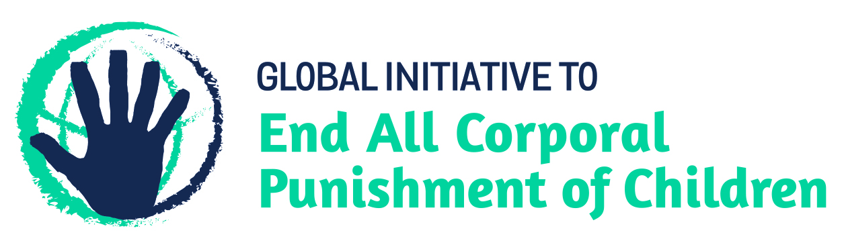
BRIEFING ON PANAMA FOR THE HUMAN RIGHTS COMMITTEE, COUNTRY REPORT TASK FORCE, 129th session (July 2020)
From the Global Initiative to End All Corporal Punishment of Children, May 2020
This briefing describes the legality of corporal punishment of children in Panama. In light of the obligation under international human rights treaties to prohibit all corporal punishment of children, the global commitment to ending violence against children – including corporal punishment – in the context of the 2030 Agenda for Sustainable Development, the recommendations of the UN Secretary General’s Study on Violence against Children, those made to Panama by the Committee on the Rights of the Child, the Committee Against Torture, the Committee on the Rights of Persons with Disabilities, those made during the Universal Periodic Review in 2010 and 2015 (which the Government accepted), and Panama’s stated commitment to law reform, we hope the Human Rights Committee will:
- raise the issue of corporal punishment of children in its List of Issues for Panama, in particular asking what progress is being made towards enacting prohibition of corporal punishment of children in all settings, and
- in its concluding observations on Panama’s fourth state party report, recommend that legislation is enacted to prohibit all corporal punishment of children, however light, in all settings, including in the home.

1 The report of Panama to the Human Rights Committee
  - Panama’s fourth periodic report to the Human Rights Committee (CCPR/C/PAN/4) does not address corporal punishment of children and its continued legality.
1.2 In light of the state’s obligation to explicitly prohibit corporal punishment in all settings, we hope the Committee will raise this issue in its review of Panama and recommend that legislation is immediately enacted to clearly and explicitly prohibit all corporal punishment of children, in all settings including the home.

2 The legality of corporal punishment of children in Panama
2.1 Summary: Corporal punishment of children in Panama is prohibited in the penal system. It is still lawful in the home, in alternative care settings, in day care and in schools.
2.2 Home (lawful): Corporal punishment is lawful in the home. Under article 319 of the Family Code 1994 those with parental authority over children have a duty and power “to reasonably and moderately correct them”, and there is a similar provision in article 443 in relation to guardians/tutors. The Family Code 1994 (art. 501) and the Criminal Code 2007 (art. 198) protect children from corporal punishment which causes physical injury but do not prohibit all corporal punishment. Other legal provisions against violence and abuse in the Family Code 1994, Law No. 38 on Domestic Violence and Abuse of Children and Adolescents 2001, the Criminal Code 2007 and the Constitution 1972 are not interpreted as prohibiting all corporal punishment.
2.3 In 2007 a project for a comprehensive law on children’s rights was submitted to Congress but as at October 2011 it had not been approved. A draft law on the promotion and integral protection of the family is under discussion, but we have no further information. The Government signalled its commitment to prohibition by accepting recommendations made during the Universal Periodic Review of Panama in 2010 to prohibit all forms of corporal punishment of children. At the second cycle UPR in 2015, the Government again accepted a recommendation to prohibit in all settings, and to repeal the power to correct in the Family and Civil Codes. In September 2015, the Government reported to the Human Rights Council that a high-level inter-institutional commission had been established to draft a comprehensive law for the protection of children. Reporting to the Committee on the Rights of the Child in November 2017, the Government stated that the draft law was in consultations phase and would shortly be presented to the Cabinet for approval. It was introduced to Parliament in 2018.
2.4 In August 2017, the Government reported to the Committee Against Torture that a technical commission (the Commission on the Prevention of Violence Against Children, COPREVINA) had been established to remedy the lack of an explicit prohibition of corporal punishment. It was specified in November 2017 that the commission would “address the updating of current legislation in the field of childhood and adolescence” within the National Strategy on the Prevention of Violence Against Children.
2.5 Alternative care settings (lawful): Corporal punishment is lawful in alternative care settings under the right of correction in the Family Code 1994.
2.6 Day care (lawful): Corporal punishment is lawful in early childhood care and in day care for older children under the right of correction in the Family Code 1994.
2.7 Schools (lawful): Corporal punishment is lawful in schools under the right of persons with parental authority to correct children in articles 319 and 443 of the Family Code (information unconfirmed).
2.8 Penal institutions (unlawful): Corporal punishment is unlawful as a disciplinary measure in penal institutions. It is explicitly prohibited in article 144 of Law No. 40 on the Special regime of criminal responsibility regarding adolescents. Law No. 55 2003 provides for respect of human rights within the penitentiary system.
2.9 Sentence for crime (unlawful): Corporal punishment is unlawful as a sentence for crime under the Criminal Code 2007 and Law No. 40 on the special regime of criminal responsibility regarding adolescents 1999.

3 Recommendations by human rights treaty bodies and during the UPR
3.1 CRC: The Committee on the Rights of the Child has on four occasions expressed concern about corporal punishment of children in the family and other settings in Panama and made recommendations to address it – in its concluding observations on the initial report in 1997, on the second report in 2004, on the third/fourth report in 2011, and on the fifth/sixth report in 2018. In 2011 and in 2018, the Committee specifically recommended revision of articles 319 and 443 of the Family Code and article 188 of the Civil Code, which provide for the “right of correction” of children.
3.2 CAT: The Committee Against Torture recommended in 2017 that Panama adopt legislation explicitly prohibiting corporal punishment of children in all settings, undertake public awareness campaigns on its harmful effects and promote positive non-violent forms of discipline as alternatives to corporal punishment.
3.3 CRPD: In 2017, the Committee on the Rights of Persons with Disabilities expressed concern that corporal punishment was not explicitly prohibited and urged Panama to repeal the legal defences in the Civil Code and the Family Code. It also recommended that prohibition is enacted of corporal punishment in all settings.
3.4 UPR: At the first cycle Universal Periodic Review in 2010, the Government accepted recommendations to explicitly prohibit all corporal punishment, stating: “The possibility of forthcoming legislation prohibiting all forms of corporal punishment against children is being considered.” In 2015 at the second cycle review, the Government again accepted a recommendation to “explicitly prohibit all corporal punishment of children in all settings, including in the home, and repeal the power to ‘correct’ in the Family Code and the Civil Code”.

Briefing prepared by the Global Initiative to End All Corporal Punishment of Children
www.endcorporalpunishment.org; info@endcorporalpunishment.org

4 January 2011, A/HRC/16/6, Report of the working group, paras. 70(15) and 70(16)
8 July 2015, A/HRC/30/7, Report of the working group, para. 90(75)
1 October 2015, Future A/HRC/30/2 Advance unedited version, Draft report of the Human Rights Council on its 30th session, para. 350
1 November 2017, CRC/C/PAN/Q/5-6/Add.1, Reply to List of issues, paras. 1 and 2
Communication with IDEMI, June 2018
See http://ohchr.org/EN/NewsEvents/Pages/DisplayNews.aspx?NewsID=21943&LangID=E, accessed 21 August 2017
1 November 2017, CRC/C/PAN/Q/5-6/Add.1, Reply to List of issues, para. 34
24 January 1997, CRC/C/15/Add.68, Concluding observations on initial report, paras. 16 and 30
30 June 2004, CRC/C/15/Add.233, Concluding observations on second report, paras. 33, 34 and 40
21 December 2011, CRC/C/PAN/CO/3-4, Concluding observations on third/fourth report, paras. 45 and 46
2 February 2018, CRC/C/PAN/CO/5-6 Advance unedited version, Concluding observations on fifth/sixth report, para. 21
[August 2017], CAT/C/PAN/CO/4, Concluding observations on fourth report, Advance unedited version, paras. 48 and 49
29 August 2017, CRPD/C/PAN/CO/1 Advance unedited version, Concluding observations on initial report, paras. 22 and 23
17 February 2011, A/HRC/16/6/Add.1, Report of the working group: Addendum
8 July 2015, A/HRC/30/7, Report of the working group, para. 90(75)

