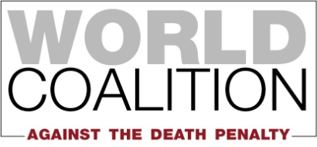

HUMAN RIGHTS COMMITTEE 129th session
(29 June to 24 July 2020)

CAMBODIA
Adoption of List of Issues

In view of the 129th Session of the Human Rights Committee, the World Coalition Against the Death Penalty (WCADP), would like to communicate several points concerning the situation of the death penalty and the ratification of OP2-ICCPR for the consideration of the List of Issues of Cambodia.

Death penalty

1. Cambodia has not carried out any executions since 1988. It has been an abolitionist country for all crimes since 1989. Its Constitution explicitly forbids the death penalty in Article 32.

2. Cambodia accepted the recommendations to ratify the Second Optional Protocol to the ICCPR during its UPRs in 2009, 2014 and 2019. Cambodia further demonstrated its commitment as regards abolition of the death penalty by voting in favor of all United Nations General Assembly resolutions for a moratorium on the use of the death penalty.

3. The World Coalition Against the Death Penalty recommends that the Human Rights Committee raises the following issue with Cambodia:
- Is Cambodia in the process of ratifying OP2-ICCPR, and if not, why?

The World Coalition Against the Death Penalty (WCADP) gathers over 164 members: human rights organizations, professional associations and local authorities on the five continents who have united to campaign for the universal abolition of the death penalty. It was founded in 2002 in Rome. Its actions include the World Day Against the Death Penalty, a ratification campaign of the United Nations Protocol aiming at the abolition of the death penalty, and a campaign for the implementation of the UNGA moratorium resolution.

