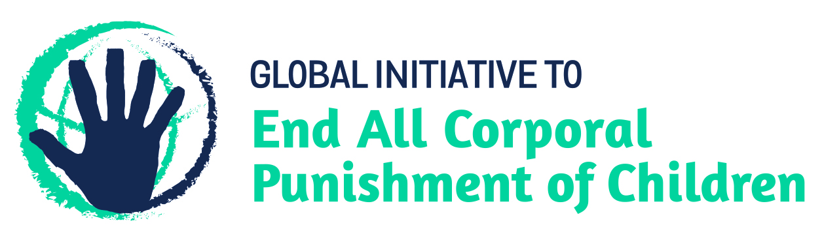
BRIEFING ON CAMBODIA FOR THE HUMAN RIGHTS COMMITTEE, COUNTRY REPORT TASK FORCE, 129th session (July 2020)
From the Global Initiative to End All Corporal Punishment of Children, May 2020
This briefing describes the legality of corporal punishment of children in Cambodia. In light of the obligation under international human rights treaties to prohibit all corporal punishment of children, the global commitment to ending violence against children – including corporal punishment – in the context of the 2030 Agenda for Sustainable Development, the recommendations of the UN Secretary General’s Study on Violence against Children, and those made to Cambodia by the Human Rights Committee and the Committee on the Rights of the Child, we hope the Human Rights Committee will:
- raise the issue of corporal punishment of children in its List of Issues for Cambodia, in particular asking what progress is being made towards enacting prohibition of corporal punishment of children in all settings, and
- in its concluding observations on Cambodia’s third state party report, recommend that legislation is enacted to prohibit all corporal punishment of children, however light, in all settings, including in the home.

1 The report of Cambodia to the Human Rights Committee
  - Cambodia’s third periodic report to the Human Rights Committee (CCPR/C/KHM/3) states that physical punishment is a criminal offence punishable by law, even for parents and guardians, referring specifically to the Law on the Prevention of Domestic Violence and the Protection of Victims 2005. This Law does not however prohibit all corporal punishment of children, excluding “traditional discipline” from its remit (see below, paragraph 2.2). The statement of illegality is further rebutted by Cambodia’s own Action Plan to Prevent and Respond to Violence Against Children 2017-2021, which commits the Government to amending domestic legislation – including the Law on the Prevention of Domestic Violence and the Protection of Victims 2005 – to explicitly prohibit all corporal punishment of children.
1.2 In light of the state’s obligation to explicitly prohibit corporal punishment in all settings, we hope the Committee will raise this issue in its review of Cambodia and recommend that legislation is immediately enacted to clearly and explicitly prohibit all corporal punishment of children, in all settings including the home.

2 The legality of corporal punishment of children in Cambodia
2.1 Summary: Corporal punishment of children in Cambodia is prohibited in schools and in the penal system. It is still lawful in the home, in alternative care settings and in day care.
2.2 Home (lawful): Corporal punishment is lawful in the home. The Civil Code states that “the parental power holder may personally discipline the child to the extent necessary” (art. 1045, unofficial translation). Article 1079 extends this “right to discipline” to the child’s guardian. Article 8 of the Law on the Prevention of Domestic Violence and the Protection of Victims 2005 states that discipline of children is not considered as violence or domestic violence. Article 48 of the Constitution 1999 states that “the State shall protect the rights of children as stipulated in the Convention on Children”, but legal provisions against violence and abuse in the Constitution 1999 and in the Marriage and Family Law 1989 and the Criminal Code 2010 are not interpreted as prohibiting all corporal punishment in childrearing.
2.3 The Government reported to the Universal Periodic Review of Cambodia in 2014 that the Ministry of Social Affairs, Veterans and Rehabilitation and the National Council for Children have set up a working group to “initiate a Law on Child Protection”. We do not know if prohibition of corporal punishment is being proposed in this context. Under examination by the Human Rights Committee in 2015, the Government confirmed that the law allows parents “to administer minor corporal punishment on their children”. In 2018, the draft Law on Child Protection was still under discussions.
2.4 The Action Plan to Prevent and Respond to Violence Against Children 2017-2021 committed to amending all relevant provisions to prohibit corporal punishment of children in all settings, in particular within the Civil Code and the Law on the Prevention of Domestic Violence and the Protection of Victims 2005, by 2019. Review of the Law on the Prevention of Domestic Violence and the Protection of Victims 2005 has reportedly begun. In reporting to the Human Rights Committee in 2019, the Government misleadingly stated that corporal punishment was “a criminal offense (…) punishable by law, even if it is done by parents or guardians”, citing the Law on the Prevention of Domestic Violence and the Protection of Victims 2005. Upon becoming a Pathfinder country with the Global Partnership to End Violence Against Children in September 2019, Cambodia expressed its commitment to prohibiting all corporal punishment of children, as a senior representative from the Ministry of Social Affairs, Veterans and Youth Rehabilitation confirmed that law reform prohibiting corporal punishment in all settings was a priority. Being a Pathfinder commits the Government to three to five years of accelerated action towards the achievement of Target 16.2 of the Sustainable Development Goals.
2.5 Alternative care settings (lawful): Corporal punishment is lawful in alternative care settings under the provision in articles 1045 and 1079 of the Civil Code for a person with parental authority to discipline the child “within necessary scope”.
2.6 Day care (lawful): Corporal punishment is lawful in day care under the provision in articles 1045 and 1079 of the Civil Code for a person with parental authority to discipline the child “within necessary scope”.
2.7 Schools (unlawful): Corporal punishment is prohibited in public and private schools in article 35 of the Education Law 2007: “The learner’s rights concerning education are: … the right to be respected and paid attention on human rights, especially the right to dignity, the right to be free from any form of torture or from physical and mental punishment….” A directive from the Ministry of Education, Youth and Sport, No. 922 MoEYS to the Director of Provincial Education, Youth and Sport on the subject of “Punishment for students” confirms that “physical punishments such as hitting, kneeling down, standing under the sun”, as well as mental punishments such as imposing copying of lessons that is impossible to achieve and making students feel bad and humiliated and punishments such as forcing students to do inappropriate tasks, are banned in all educational institutions throughout the country. Article 12 of the Sub-Decree on the Teachers Professional Code reportedly states that “teachers shall not physically and emotionally punish the learners that possible affect their learning”.
2.8 Penal institutions (unlawful): Corporal punishment is unlawful as a disciplinary measure in penal institutions under article 5 of the Juvenile Justice Law 2016: “All persons performing any function concerning to minor shall ensure the observance of the following principles: … shall be prohibited torture, corporal punishment, or other treatment which is cruel, inhumane, or degrading in all forms” (unofficial translation). Article 2 states that the aims of the Law are to establish rules and procedures to deal with minors who have committed criminal offences. According to article 38 of the Constitution 1999, “Coercion, physical ill-treatment or any other mistreatment that imposes additional punishment on a detainee or prisoner shall be prohibited”.
2.9 Sentence for crime (unlawful): Corporal punishment is unlawful as a sentence for crime. There is no provision for judicial corporal punishment in the Criminal Code or the Criminal Procedure Code 2007.

3 Recommendations by human rights treaty bodies
3.1 HRC: The Human Rights Committee has in 2015 expressed concern at the continued legality of corporal punishment in the home and recommended that the Government put an end to its practice in all settings, including through legislative measures.
3.2 CRC: In 2011, the Committee on the Rights of the Child recommended that corporal punishment is prohibited in all settings, including the family and that provisions authorising it are repealed.

Briefing prepared by the Global Initiative to End All Corporal Punishment of Children
www.endcorporalpunishment.org; info@endcorporalpunishment.org

5 August 2019, CCPR/C/KHM/3, Third report, paras. 34 and 35
21 November 2013, A/HRC/WG.6/18/KHM/1, National report to the UPR, para. 91
23 March 2015, CCPR/C/SR.3139, Summary record of 3139th session, para. 34
[2018], CRC/C/KHM/5-6, Fifth/sixth report, para. 7
Information provided to the Global Initiative, June 2019
5 August 2019, CCPR/C/KHM/3, Third report, paras. 34 and 35
http://unicefcambodia.blogspot.co.uk/2016/09/case-study-long-road-to-juvenile.html, accessed 15 May 2017
[April 2015], CCPR/C/KHM/CO/2 Advance Unedited Version, Concluding observations on second report
3 August 2011, CRC/C/KHM/CO/2-3, Concluding observations on second/third report, paras. 38, 39, 40 and 41

