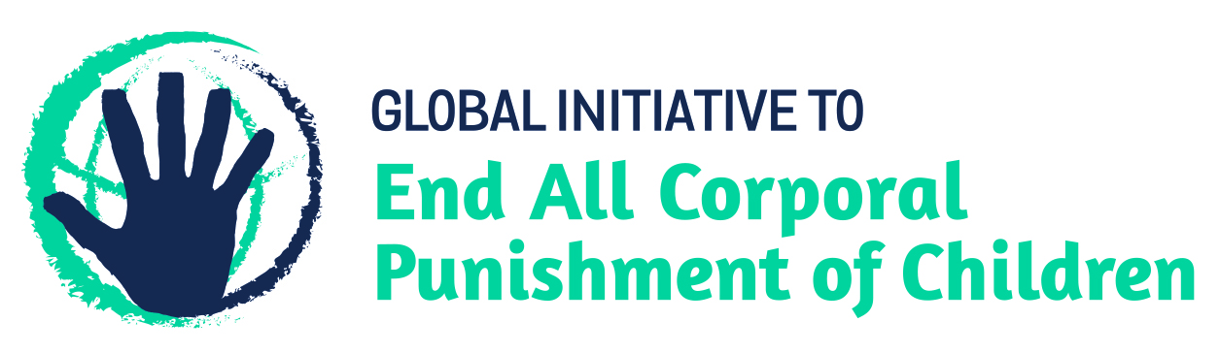
BRIEFING ON THE CENTRAL AFRICAN REPUBLIC FOR THE HUMAN RIGHTS COMMITTEE, COUNTRY REPORT TASK FORCE, 125th session (March 2019)
From the Global Initiative to End All Corporal Punishment of Children, January 2019
This briefing describes the legality of corporal punishment of children in the Central African Republic. In light of the obligation under international human rights treaties to prohibit all corporal punishment of children, the global commitment to ending violence against children – including corporal punishment – in the context of the 2030 Agenda for Sustainable Development, the recommendations of the UN Secretary General’s Study on Violence against Children, and those made to the Central African Republic by the Committee on the Rights of the Child, the Committee on Economic, Social and Cultural Rights, and during the Universal Periodic Review, we hope the Human Rights Committee will:
- raise the issue of corporal punishment of children in its List of Issues for the Central African Republic, in particular asking what progress is being made on enacting the draft Child Protection Code to explicitly prohibit all corporal punishment of children and repeal the power to “correct”, and
- in its concluding observations on the Central African Republic’s third/fourth state party report, recommend that the draft Child Protection Code is amended to explicitly prohibit all corporal punishment of children, in all settings including the home, and to repeal all legal defences for its use, and enacted as a matter of priority.

1 The report of the Central African Republic to the Human Rights Committee
  - The Central African Republic’s third/fourth periodic report to the Human Rights Committee (CCPR/C/ CAF/3-4) does not address the legality and prevalence of corporal punishment of children. The provisions of the Constitution and the Penal Code 2010 highlighted in the report are not interpreted as prohibiting all corporal punishment and article 580 of the Family Code refers to parents’ power to “correct” children.
1.2 In light of the state’s obligation to explicitly prohibit corporal punishment in all settings, we hope the Committee will raise this issue in its review of the Central African Republic and recommend that the draft Child Protection Code is amended to explicitly prohibit all corporal punishment of children, in all settings including the home, and to repeal all legal defences for its use, and enacted as a matter of priority.

2 The legality of corporal punishment of children in the Central African Republic
2.1 Summary: Corporal punishment of children in the Central African Republic is unlawful as a sentence for a crime but it is still not prohibited in the home, in alternative care and day care settings, in schools and in penal institutions.
2.2 Home (lawful): Corporal punishment is lawful in the home. Article 580 of the Family Code 1997 states that parental authority includes the power “to reprimand and correct to the extent compatible with the age and level of understanding of the child”. Provisions against violence and abuse in the Family Code, the Penal Code 2010, the Constitution 2016, Imperial Order No. 79/077 covering protection of youth 1979, and Law No. 280 1961 are not interpreted as prohibiting corporal punishment in childrearing. Act No. 06.032 2006 protecting women against violence defines violence against women as “including all acts of violence directed against females and which cause or might cause an adverse effect or physical, sexual or psychological suffering, including the threat of such acts and constraint or arbitrary deprivation of liberty, whether in public or private life” (art. 1), but it does not explicitly prohibit all corporal punishment in childrearing.
2.3 A new Family Code has been drafted but has yet to be adopted by the National Assembly: we have yet to verify reports that it would prohibit corporal punishment. The Criminal Code is being revised and a new Child Protection Code is being drafted. Article 57 of the draft Child Protection Code, as sent to the Committee on the Rights of the Child in December 2016, states that “the child has the right to be protected against all forms of violence. Parents must administer family discipline in a way which ensure that the child is treated with humanity. The State ensures that discipline is administered in such a way that the child is treated with humanity in schools, public institutions or private formal institutions” (unofficial translation). The Government stated in February 2017 that corporal punishment would be prohibited shortly. We have no further information.
2.4 Alternative care settings (lawful): Corporal punishment is lawful in alternative care settings under the power of those with parental authority to “reprimand and correct” the child in article 580 of the Family Code 1997.
2.5 Day care (lawful): Corporal punishment is lawful in day care under the power of those with parental authority to “reprimand and correct” the child in article 580 of the Family Code 1997.
2.6 Schools (lawful): Corporal punishment is lawful in schools. Imperial Order No. 78/034 (1978) covers the physical and moral protection of young persons in residential educational institutions or boarding schools, but does not prohibit corporal punishment.
2.7 Penal institutions (lawful): There is no explicit prohibition of corporal punishment as a disciplinary measure in penal institutions. We have been unable to examine the full text of the Decree No. 160087 of 18 February 2016 on the organization, operation and internal regulations of prisons, but there are no indications it prohibits corporal punishment.
2.8 Sentence for crime (unlawful): There is no provision for judicial corporal punishment in the Penal Code 2010, the Penal Procedure Code 2010 or the Law on the Juvenile Court 2002.

3 Recommendations by human rights treaty bodies and during the UPR
3.1 CRC: In 2000, the Committee on the Rights of the Child expressed concern about corporal punishment of children by the police and recommended that this be ended. In 2017, the Committee recommended that corporal punishment is prohibited in all settings through the draft Child Protection Code.
3.2 CESCR: The Committee on Economic, Social and Cultural Rights expressed concern in 2018 that the Family Code allowed corporal punishment in the family and recommended that legislation is amended to explicitly prohibit corporal punishment in all settings.
3.3 UPR: Central African Republic was examined in the first cycle of the Universal Periodic Review in 2009 and in the second cycle in 2013. No recommendations were made specifically concerning corporal punishment of children, but the Government accepted a number of recommendations to strengthen the protection of children, including through law reform. A recommendation to prohibit corporal punishment in all settings was extended during the Central African Republic’s third cycle examination; the Government is yet to respond.

Briefing prepared by the Global Initiative to End All Corporal Punishment of Children
www.endcorporalpunishment.org; info@endcorporalpunishment.org

12 November 2018, CCPR/C/CAF/3-4, Third/fourth report, paras. 152, 154, 155, 156 and 157
7 February 2017, CRC/C/SR.2171, Summary records of 2171st meeting, para. 23
18 October 2000, CRC/C/15/Add.138, Concluding observations on initial report, paras. 44 and 45
8 March 2017, CRC/C/CAF/CO/2, Concluding observations on second report, paras. 6, 7, 38 and 39
[March 2018], E/C.12/CAF/CO/1 Advance unedited version, Concluding observations on initial report, paras. 35 and 36
4 June 2009, Report of the working group, paras. 74(17), 74(19) and 74(31); 6 January 2014, A/HRC/25/11, Report of the working group, paras. 104(1) and 105(25)
13 November 2018, A/HRC/WG.6/31/L.9 Unedited version, Draft report of the Working Group, para. 6(186)

