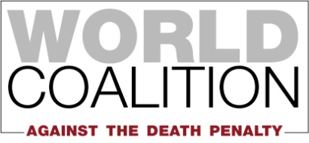

HUMAN RIGHTS COMMITTEE 129th session
(29 June to 24 July 2020)

ARMENIA
Adoption of List of Issues

In view of the 129th Session of the Human Rights Committee, the World Coalition Against the Death Penalty (WCADP), would like to communicate several points concerning the situation of the death penalty and the ratification of OP2-ICCPR for the consideration of the List of Issues of Armenia.

Death penalty

1. Armenia is an abolitionist country for all crimes and has never carried out any executions.

2. Article 15 of the Constitution of the Republic of Armenia, states “Everyone shall have the right to life. No one may be sentenced or subjected to the death penalty.”

3. Armenia is the only country in the world that has ratified Protocol No. 6 and signed Protocol No. 13to the European Convention for the Protection of Human Rights and Fundamental Freedoms but has not ratified the Second Optional Protocol to the International Covenant on Civil and Political Rights (OP2-ICCPR).

4. Armenia signed the Second Optional Protocol to the ICCPR on 26 September 2019.

5. During its 3rd Universal Periodic Review by the Human Rights Council in June 2020, Armenia was recommended to proceed to the swift ratification of the Second Optional Protocol to the International Covenant on Civil and Political Rights, aiming at the abolition of the death penalty.

6. The World Coalition Against the Death Penalty recommends that the Human Rights Committee raises the following issue with Armenia:
- Is Armenia in the process of ratifying OP2-ICCPR, and if not, why?

The World Coalition Against the Death Penalty gathers over 164 members: human rights organizations, professional associations and local authorities on the five continents who have united to campaign for the universal abolition of the death penalty. It was founded in 2002 in Rome. Its actions include the World Day Against the Death Penalty, a ratification campaign of the United Nations Protocol aiming at the abolition of the death penalty, and a campaign for the implementation of the UNGA moratorium resolution.

