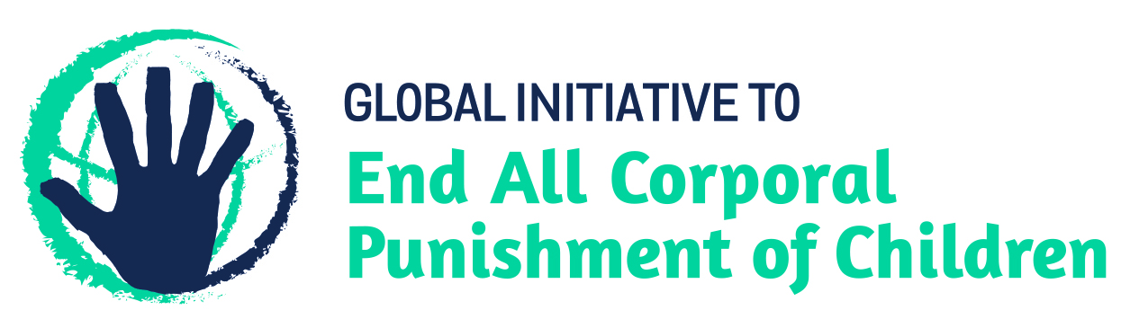
BRIEFING ON TUNISIA FOR THE HUMAN RIGHTS COMMITTEE, 128th session (March 2020)
From the Global Initiative to End All Corporal Punishment of Children, January 2020
This briefing provides an update on the legality of corporal punishment of children in Tunisia since its previous examination by the Committee in 2008. We are delighted to inform the Committee that Tunisia has now prohibited corporal punishment in all settings, including the home.
We hope the Committee will, in its concluding observations on Tunisia’s sixth periodic report, welcome the explicit prohibition of all corporal punishment of children in Tunisia and recommend that all measures be taken to ensure implementation of the prohibition of corporal punishment in all settings, including the home.

1 Prohibition of all corporal punishment of children in Tunisia
  - Corporal punishment is unlawful in all settings, including the home. Article 319 of the Penal Code punishes assault and violence which does not lead to serious or lasting consequences for the victim. Prior to law reform in 2010, it also stated that “correction of a child by persons in authority over him is not punishable”. Law No. 2010-40 of 26 July 2010 amended article 319 to explicitly repeal this clause, making it a criminal offence to assault a child even lightly. Publication of the law in the Official Gazette in July 2010, was accompanied by a statement from the Constitutional Council that the new law is wholly compatible with the Constitution and its effect is to make the provisions against light assault in article 319 of the Penal Code equally applicable to “correction” of children.
  - Serious assault is punishable under other articles in the Penal Code. The Code of Child Protection 1995 (amended 2006) protects children from “usual ill-treatment”, defined in article 24 as “subjection of the child to torture, repeated violations of his physical integrity, or his detention, or the habit of depriving him of food, or committing any brutal act which is likely to affect the emotional or psychological well being of the child”.

Briefing prepared by the Global Initiative to End All Corporal Punishment of Children
www.endcorporalpunishment.org; info@endcorporalpunishment.org

