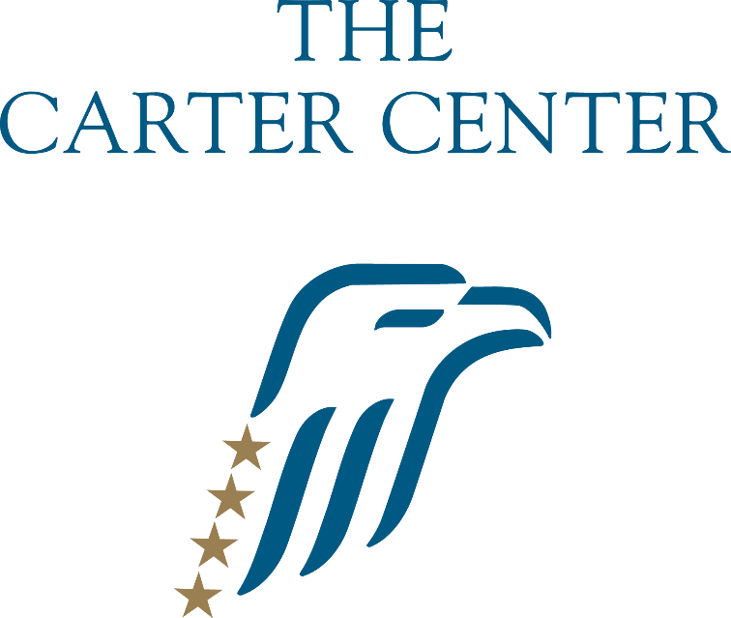

Kenya

NGO Submission to the U.N. Human Rights Committee

Prior to the Review of the 4th Periodic State Report
131st Session
(March 2021, Geneva)

Submitted by: The Carter Center
Contact name: David Carroll, Director, Democracy Program
Contact email: djcarro@emory.edu
Website: www.cartercenter.org

Reporting Organization

The Carter Center is a not-for-profit, nongovernmental organization that has helped to improve life for people in more than 80 countries by resolving conflicts; advancing democracy, human rights, and economic opportunity; preventing diseases; and improving mental health care. The Carter Center was founded in 1982 by former U.S. President Jimmy Carter and his wife, Rosalynn, in partnership with Emory University to advance peace and health worldwide.

The Carter Center’s Democracy Program works globally to promote democratic elections and governance consistent with human rights. The Center has monitored more than 100 elections in 39 countries since 1989, forging many of the techniques now common to the field. Recognizing that democratic transitions involve much more than elections, the Center also conducts long-term monitoring of political transitions and works to strengthen civil society organizations to support democratic governance. The Democratic Election Standards (DES) initiative aims to build consensus on standards for democratic elections, based on state obligations under public international law.

The Carter Center in Kenya

The Carter Center first deployed international observation missions in Kenya to assess the 2002 presidential and parliamentary elections. A summary of its findings can be found here. Additionally, the Center observed the national elections of 2012 and 2017. Key summaries of these missions can be found here and here, respectively. This report is based on data collected by The Carter Center between February 2015 and March 2018.

Issues and Suggested Questions for the Human Rights Committee

Article 3 and Article 25: Equality between Men and Women
Article 2: Right to an Effective Remedy

Article 3 and 25

In the list of issues in relation to the fourth periodic report of Kenya, the Human Rights Committee asked the State to report on measures taken to facilitate and improve women’s participation in the public and private sectors. In particular, the Committee asked for information on what steps the state had taken to implement the constitutional provision prohibiting more than two thirds of any elected body being of the same gender.

In its response, Kenya stated that the “Representation of Special Interest Groups Laws (Amendment) Bill 2019 is currently before Parliament. The bill requires political parties to ensure that at least a third of its candidates for parliamentary and county assembly elections are of either gender; bars the Independent Electoral and Boundaries Commission (IEBC) from accepting lists of candidates from political parties that do not meet the gender rule; and proposes that 20 percent of the political parties’ cash be distributed according to the number of the special interest groups elected as an incentive for political parties to ensure more women, youth and persons with disability win elective seats.”

In addition, the state asserted that the Political Parties Primaries Bill 2020 is a legal framework for the conduct of political party primaries that seeks to ensure that political parties comply with the constitutional provisions on non-discrimination, inclusion and gender equity when conducting the party’s primaries.

In its report, the state also outlined several steps that it had taken such as holding dialogue meetings with political parties to attain zero tolerance of violence against women during campaigns and elections. Capacity-building forums were held to equip aspirants of special interest groups with knowledge and skills on how to succeed in the political arena. Men were also engaged in the fora and addressed the culturally-entrenched attitudes about women's involvement in political and electoral life that may potentially trigger election violence.

While it is commendable that the state is taking steps to address the ongoing issue of inequality between men and women in political participation and representation, none of the outlined steps will address the issue of implementation of the constitutional requirement that no elected body be composed of more than two-thirds of one gender. As the state admitted in its response, “as outlined in Kenya’s 4th periodic country report on the Covenant, Kenya continues to face challenges with regard to the implementation of the gender rule in the political representation of women in parliament.”

Attempts were made in 2016, 2017, 2018 and 2019 to introduce legislation to implement Article 81(b) of the Constitution, which requires that not more than two-thirds of the members of elective public bodies shall be of the same gender. On all these occasions, parliament debated the matter, but failed to pass the bills despite a constitutional deadline. Parliament’s continued failure to pass legislation to implement the two-thirds gender rule enshrined in the constitution not only undermines other efforts made to achieve equality between women and men in the political sphere but also the adherence to the rule of law in Kenya.

Article 2(3) of the ICCPR and Article 8 of the Universal Declaration of Human Rights guarantees the right to an effective remedy by the competent national tribunals for acts violating the fundamental rights granted by the constitution or by law. There can be no question that Article 81(b) of the Kenyan Constitution grants a fundamental right to the less-represented gender by requiring that not more than two-thirds of the members of elective or appointive bodies shall be of the same gender.

Although the courts have been asked several times to take immediate action to implement the two-thirds gender rule or to declare any parliament elected without complying with the rule unconstitutional, the courts to date have refused to take the necessary steps to enforce the rule. This is a denial of an effective remedy for the violation of a fundamental human right guaranteed by the Kenyan Constitution.

Recommendation: The Carter Center recommends that the committee request a concrete plan from the state to implement the constitutional provision with strict deadlines. If the parliament fails to act within the deadline then the committee should recommend that the state seek a court order implementing a resolution to the matter. The judiciary has an independent obligation to ensure that the rule of law is upheld through its role in seeing that the provisions of the constitution are enforced within a reasonable time frame.

Article 6: Right to Life

The Carter Center in its submission prior to the list of issues noted that the charged campaign environment during the 2017 elections, coupled with the violent protests and excessive use of force by security, increased the vulnerability of women. Following the Aug. 8, 2017 elections, there were reports of human rights violations, including beatings and killings by security forces as well as sexual violence against women and girls.

The committee, in the list of issues in relation to the fourth periodic report requested the state to provide information about measures taken by the State party to address enforced disappearances, extrajudicial killings and other practices related to the unlawful use of force by State and non-State actors, including during the 2017 general election period and its aftermath.

In its response to the list of issues, the state responded that they had established the Independent Policing Oversight Authority (IPOA) to investigate and recommend prosecution of unlawful practices by the law enforcement officers. They also cited international standards on the use of force to which Kenya adheres and what steps the state takes to ensure that the standards are respected.

The response of the state lacks any detail as to what steps they have taken since the 2017 elections to specifically address the excessive use of force and crimes committed by the security forces during the election period and its aftermath. Many of the cited steps taken by the state were in place before the 2017 elections and the state has not provided any additional information on steps it has taken either to enforce existing standards and guidelines or to reform them so that the violence and excessive use of force that occurred during the 2017 elections does not occur again during future elections.

Recommendation: The Carter Center recommends that the committee ask the state to produce a plan that details the steps it will take before the next election to ensure that the excessive use of force and violence that occurred in 2017 does not occur during future elections.

