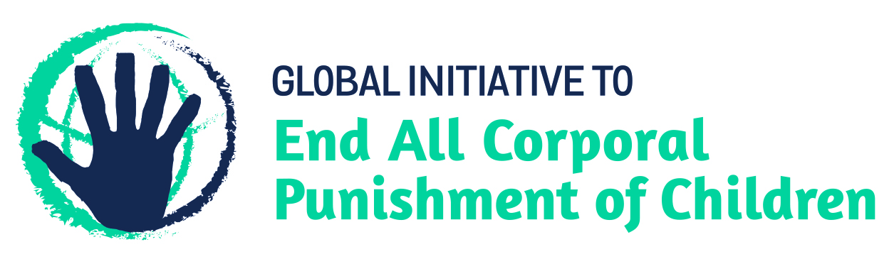
BRIEFING ON DOMINICA FOR THE HUMAN RIGHTS COMMITTEE, 128th session (March 2020)
From the Global Initiative to End All Corporal Punishment of Children, January 2020
This briefing provides an update on the legality of corporal punishment of children in Dominica in light of the new opportunities for law reform. Corporal punishment is still lawful in every setting, including the home, in alternative care and day care settings, in schools, in penal institutions and as a sentence for a crime.
We hope the Committee will recommend, in its concluding observations on Dominica’s initial state party report, that legislation is enacted to prohibit all corporal punishment of children, however light, in all settings including the home and as a sentence for a crime, as a matter of priority.

1 Updates to the legality of corporal punishment of children in Dominica
  - The Government is yet to give any clear indication of a commitment to prohibit all corporal punishment of children. The 2018 National Child Protection Action Plan does not refer to corporal punishment and multiple recommendations to prohibit all corporal punishment extended during the Universal Periodic Review in 2019 were noted (not supported) without comments.
  - The Government reported in 2019 that a Status of Children Bill, a Children (Care and Adoption) Bill and a Child Justice Bill were being discussed in the Cabinet before being introduced to Parliament. The text of the Bills as of October 2018 did not prohibit all corporal punishment of children. Article 29(1)(c) of the Children (Care and Adoption) Bill allows a person authorised to provide care for a child to “correct and manage the behaviour of the child”.
  - The Child Justice Bill, which has been in discussion for several years, was opened for comments in October 2018. The Bill prohibits corporal punishment of children as a sentence for a crime under draft article 69(1), stating: “A sentence of life imprisonment or any form of corporal punishment shall not be imposed on a child”, though it does not repeal all of the existing legislation allowing judicial corporal punishment. As of July 2019, the Bill was being finalised by the Cabinet before introduction to Parliament. In 2019, the Government had also stated that while legislation allowed for judicial corporal punishment, “there had been no such sentence imposed on a child in the past 20 years” and Dominica “remained committed to updating its legislation related to the rights of children, to reflect current-day realities”.

Updated briefing prepared by the Global Initiative to End All Corporal Punishment of Children
www.endcorporalpunishment.org; info@endcorporalpunishment.org

9 July 2019, A/HRC/42/9, Report of the Working Group, paras. 124(119), 124(121), 124(124), 124(125), 124(126), 124(127), 124(128), 124(131) and 124(132); 10 September 2019, A/HRC/42/9/Add.1, Report of the Working Group: Addendum
9 July 2019, A/HRC/42/9, Report of the Working Group, para. 33
9 July 2019, A/HRC/42/9, Report of the Working Group, para. 33
9 July 2019, A/HRC/42/9, Report of the Working Group, para. 30

