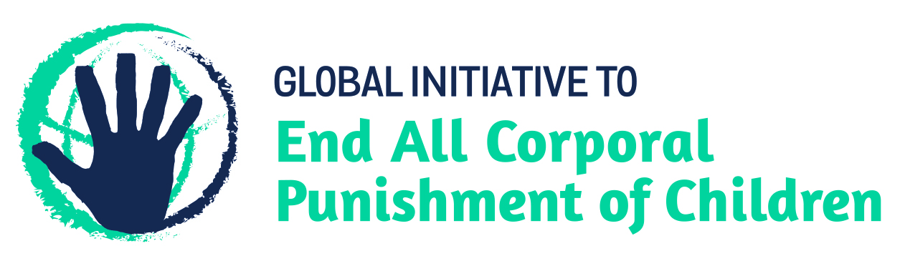
BRIEFING ON ANGOLA FOR THE HUMAN RIGHTS COMMITTEE, 125th session (March 2019)
From the Global Initiative to End All Corporal Punishment of Children, January 2019
This briefing provides an update on the legality of corporal punishment of children in Angola in light of the state party’s reply to the list of issues. Corporal punishment is still lawful in the home, in alternative care and day care settings, in schools and in penal institutions.
We hope the Committee will recommend, in its concluding observations on Angola’s second state party report, that legislation prohibiting all corporal punishment of children, however light, in all settings, and repealing all legal defences for its use, is drafted and enacted as a matter of priority.

1 Angola’s reply to the List of issues
  - Angola’s reply to the list of issues (CCPR/C/AGO/Q/2/Add.1) misleadingly reports that the “corporal punishment of a child by any person in any setting is considered an offence which, depending on how it is characterized, can be classified as simple assault or negligent assault causing serious bodily injury”.
  - There is no explicit prohibition of corporal punishment of children in Angola – provisions against violence and abuse in the Child Law 2012 and the Penal Code are not interpreted as prohibiting all corporal punishment of children, however light. In fact, during its examination of Angola in June 2018, the UN Committee on the Rights of the Child expressed concern that Angola “submits that corporal punishment is considered a crime in all instances when this statement is not supported by the laws”, recommending that the Government amend domestic legislation to explicitly prohibit the use of corporal punishment in all settings as a matter of urgency.
  - Article 10 of the Child Law indeed states that “in safeguarding the right to respect of dignity and physical, mental or moral integrity of the child, he or she has the right to be guided and to be disciplined in accordance with his or her age, and his or her physical and mental condition. No corrective measure applied to the child can be justified if by virtue of his or her tender age or any other reason the child is unable to understand the purpose intended by the measure.” This provision provides for the concept of “justifiable correction” and must be repealed and an explicit prohibition of all corporal punishment of children must be enacted.

Updated briefing prepared by the Global Initiative to End All Corporal Punishment of Children
www.endcorporalpunishment.org; info@endcorporalpunishment.org

3 December 2018, CCPR/C/AGO/Q/2/Add.1, Reply to list of issues, para. 108
1 June 2018, CRC/C/AGO/5-7 Advance unedited version, Concluding observations on fifth/seventh report, paras. 4, 20 and 21

