ҚАЗАҚСТАН РЕСПУБЛИКАСЫ  ТӘУЕЛСІЗ КӘСIПОДАҚТАРЫНЫҢ  КОНФЕДЕРАЦИЯСЫ  Қазақстан Республикасы, 160006  Шымкент қ. Шаяхметова к-сi  Жана Турмыс оф.12  Тел.\факс: +7 (7252) 47 9072  E-mail: larisa_harkova@mail.ru | 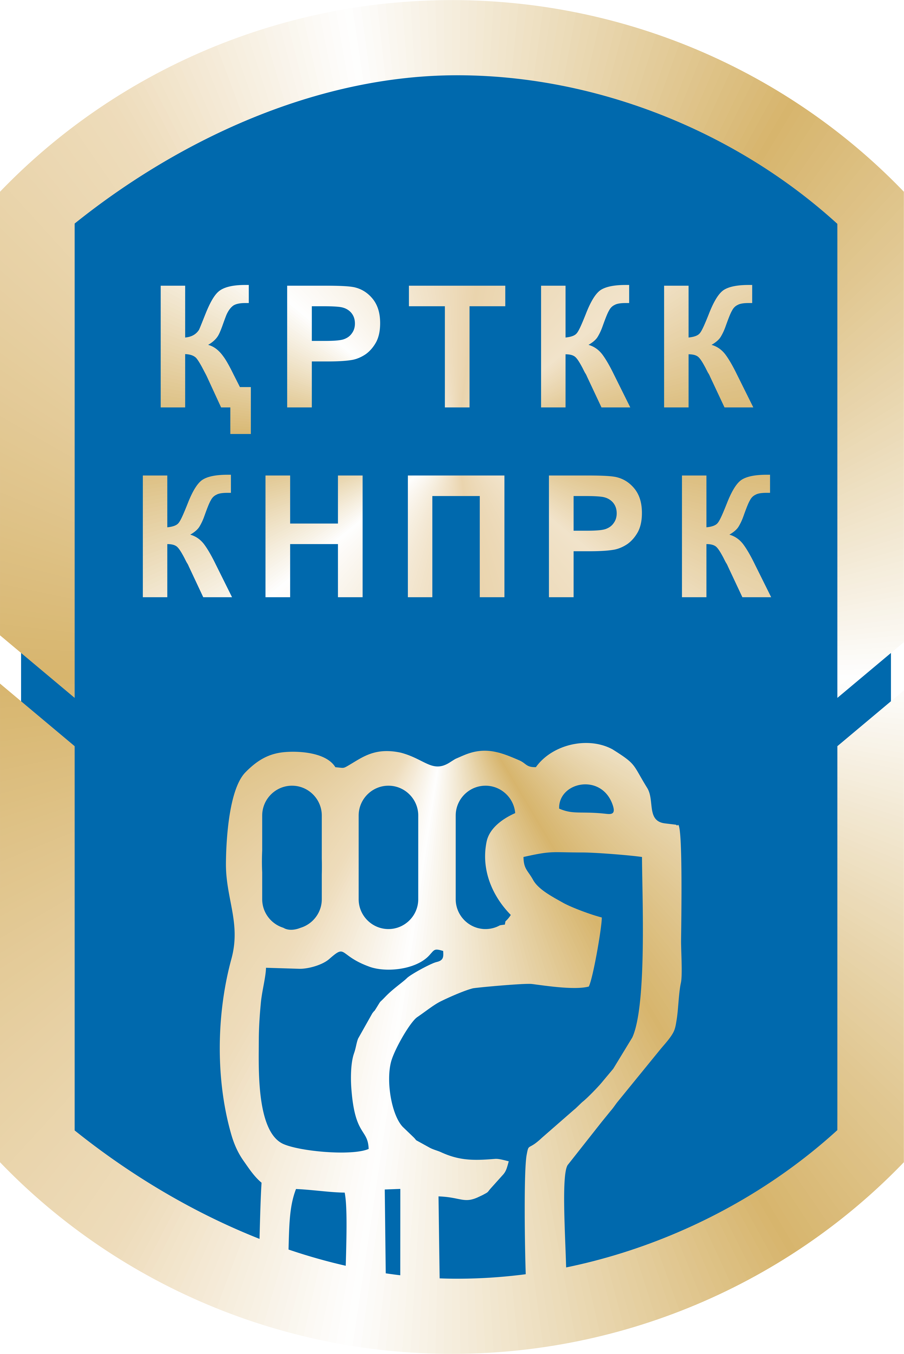  CONFEDERATION OF  INDEPENDENT TRADE UNIONS OF KAZAKHSTAN | КОНФЕДЕРАЦИЯ  НЕЗАВИСИМЫХ ПРОФСОЮЗОВ  РЕСПУБЛИКИ КАЗАХСТАН  Республика Казахстан, 160006  г. Шымкент, ул.Шаяхметова  Жана Турмыс оф.12  Тел.\факс: +7 (7252) 47 9072  E-mail: larisa_harkova@mail.ru

INFORMATION ON IMPLEMENTATION BY THE REPUBLIC OF KAZAKHSTAN OF THE RECOMMENDATION 54 OF THE CONCLUDING OBSERVATIONS OF THE UN COMMITTEE ON HUMAN RIGHTS

In paragraph 53 of the Concluding Observations, the Committee expressed concerns by the limitation on the freedom of association and especially:
“… (d) the restrictive legal framework regulating strikes and the mandatory affiliation of trade unions to regional or sectorial federations under the 2014 Act on Trade Unions may adversely affect the right to freedom of association under the Covenant…”

In the paragraph 54, the Committee recommended to bring State regulations and practice governing the legal frameworks regulating strikes and trade unions into full compliance with the provisions of articles 19, 22 and 25 of the Covenant.

However, the practical steps taken by the state over the past year are not only non-directed at the implementation of these recommendations, but also run counter to them.

In November 2016, the Ministry of Justice of the Republic of Kazakhstan (MoJ RK) appealed to the court demanding the liquidation of the Confederation of Independent Trade Unions of Kazakhstan (CITUK), arguing that since preliminary registration of CITUK in February 2016, the organization failed to provide, within 6 months, the information on registration of the necessary number of territorial associations of trade unions, as well as branch and local trade unions, as was demanded by the new Law of the RK on trade unions adopted in 2014.

Ministry of Justice of the Republic of Kazakhstan stated in its legal claim that the CITUK was created by four founders: the trade union of mass media and telecommunications workers, the social and domestic trade union “Justice”, the trade union of health and social development workers, the trade union of workers in the fuel and energy complex. In Ministry's opinion the above-mentioned four founders did not comply with the requirements of the law and did not provide documents confirming their registration in the statutory period, that is, until August 15, 2016.

However, the facts show that the state deliberately prevented the registration of trade unions and, correspondingly, the CITUK. Thus, the “Branch Trade Union of Mass Media and Telecommunications Workers” was registered on December 11, 2015. Its head office is in Almaty. There are 3 branches and 6 primary organizations on the trade union account. Before the expiry of the six-month period in August 2016, only one branch was able to pass registration. To confirm the registration in Karaganda, for example, documents to the Justice Department simply were not accepted without giving any reasons, and were admitted after a six-month period, that is, on August 26, 2016.

A similar situation has arisen with the registration of other independent trade unions. Everywhere throughout the country, trade unions affiliated with the CITUK, their branches and primary organizations were refused admission of their documents, suspended registration for insignificant reasons, or refused to register at all.

The CITUK repeatedly informed the Ministry of Justice of the Republic of Kazakhstan about violation by the regional departments of justice of the terms of registration of branches and local trade unions, however, no measures were taken.

After a long and difficult struggle, the CITUK was registered only in February 2016 and has existed less than a year. Branch structures of this trade union association for a short time were able to register local trade unions, obtain registration of branches and organize primary trade union organizations. As a result, 21 branches, 20 primary trade union organizations and 9 local trade union organizations, which are the basis of the activity of the CITUK, were able to pass registration but with great difficulty while overcoming obstacles of various kinds plotted by the departments of justice.

Deliberate obstacles to the activities of independent trade unions were created by the Ministry of Justice of the Republic of Kazakhstan since 2015. By the orders of the Ministry of Justice on May 25, June 12, June 22, July 13, 2015, the CITUK activity was repeatedly stopped due to the absence of affiliated branch organizations, non-presentation of documents confirming the right for real estate, “other documents provided for by civil law”. Departments of justice indicated the refusal to register the public associations in the orders on refusal to register the changes of constituent documents. All this suggests the intention to simply liquidate the independent trade unions in Kazakhstan.

In the end, by the decision of the court in January 2017, the CITUK was liquidated.

After the decision to liquidate the CITUK on January 5, 2017, oil workers of the oilfield service company Oil Construction Company announced a hunger strike in protest. In history of trade union movement in Kazakhstan, this was the first solidarity action in support of the republican CITUK center. A two-week hunger strike of workers took place at the office of the trade union of the enterprise in the city of Aktau and at place of work of oil workers in Kalamkas and Zhetybai fields. But the court found the hunger strike illegal and the prosecutor of the city of Aktau demanded that the oil workers comply with the court decision and regarded their protest as “a protest against the state.” Workers on January 22 were forced to leave the office of the union and stop the hunger strike. From January 19 to 24, during the trials, the judges demanded that 63 oil workers pay fines of 20 to 50 MCI and compensate for the total amount of 3,854,870 tenge (about 12,000 euros).

An employee of the oilfield service company Oil Construction Company Meirambek Kuantayev climbed on a construction crane on the Kalamkas deposit of the Mangistau region on the morning of January 11. The oil worker this way protested against the criminal prosecution of the president of the liquidated CITUK, Larisa Kharkova, and demanded that the court’s decision to liquidate this trade union organization be canceled. After the hunger strike, firing of protesters began.

In the order signed by Serik Abdenov, the director of Oil Construction Company oilfield service company (by the way, the former Minister of Labor and Social Protection of Population of Kazakhstan, who headed the agency from 2012 to 2013, and also participated in working out of a draft law “On Trade Unions”) stated that the employee refusing to accept food violated the rules of labor regulations. It is noted that the basis for the order was the court’s decision.

Thus, the right to carry out strikes and actions in protecting the trade union association was violated.

On January 20, 2017, the chairman of the trade union of Oil Construction Company (OCC) oil service company Amin Yeleusinov and the labor inspector of this trade union Nurbek Kushakbayev were detained and taken out of Aktau to Astana and arrested on criminal charges.

Amin Yeleusinov was charged under part 4 of Article 189 of the Criminal Code of the Republic of Kazakhstan “Assignment or embezzlement of entrusted property”, that is, allegedly the embezzlement of trade union funds.

Nurbek Kushakbayev was accused under part 2 of article 402 of the Criminal Code of the Republic of Kazakhstan “Actions provoking to continue participation in a strike recognized illegal by the court”.

The basis for the accusation was that 170 workers from LLP “Techno Trading LTD” staged a strike from December 15 to 26, 2016. They demanded the resignation of the current director of the company, acceleration of signing of the draft additional agreement to the collective agreement, restoration of three dismissed workers, and cancellation of the order to apply disciplinary measures taken against employees during the period from December 15 to December 24, 2016. On December 28, 2016, by a decision of the Karakiyan district court, this strike was declared illegal.

From December 23 to 26, 2016, 80 workers from another workshop, repairing oilfield equipment, conducted an unauthorized strike on their territory in Birlik settlement, during which similar demands were put forward. By the decision of the Munayli district court, the strike was also found to be illegal.

Nurbek Kushakbayev’s lawyers said that the prosecution’s party, represented by the prosecutor, did not submit the facts of the crime and did not prove his guilt. In addition, the pre-trial investigation and the judicial investigation were conducted with an accusatory bias. Namely: the trial was held in a hurry, every day from morning till night, during breaks N. Kushakbayev was escorted from the courtroom by convoy. In addition, lawyers did not have the opportunity to fully prepare for the trials.

On April 7, Almaty District Court No. 2 of Astana issued a verdict - Nurbek Kushakbayev was found guilty and sentenced to 2,5 years of imprisonments with a ban on engaging in public activities for up to 2 years. The court did not take into account anything, including the presence of the defendant’s small child.

Moreover, Judge Ayzhan Kulbayeva decided to satisfy the civil suit of LLP “Techno Trading LTD”. That is, Nurbek Kushakbayev will have to pay more than 25 million tenge to the oilfield services company (over 75,000 euros).

On May 16, a judge of the Almaty District Court No. 2 of Astana found Amin Yeleusinov guilty under Article 176, part 4, item b of the Criminal Code of the Republic of Kazakhstan and sentenced him to 2 years of imprisonment with confiscation of property allegedly obtained by criminal means. Amin Yeleusinov was accused under four articles of the Criminal Code of the Republic of Kazakhstan: “Assignment or embezzlement of entrusted foreign property in especially large amounts” (presumably to the amount of more than 14.6 million tenge), “Insulting a representative of authority committed in public or using media or telecommunications networks”, “Disobedience to the representative of authority” and “Use of violence against a representative of authority”.

At the same time, 500 members of the trade union, who, according to investigators, were robbed by Eleusinov, sent a letter in his support. Eleusinov wrote a statement on the conclusion of procedural agreement and admitted fault to the charges against him. The terms of the agreement are not disclosed.

Since January 2017, the criminal prosecution continues over three denouncements in relation to the CITUK chairman Larisa Kharkova. As per the first denouncement of a person who left the local trade union, she was charged with appropriating funds in the amount of 3,000,000 tenge (about 9,000 euros).

On January 9, 2017, searches were conducted at the office of the CITUK and in the apartment where Kharkova lives and all the accounting and office documents were seized.

The investigative authorities conducted six examinations on all documents of the CITUK. But the audit and forensic examinations initiated by the investigators, as well as the tax inspection, did not confirm the embezzlement.

Then the police officers practically forced the two former leaders of the trade union to write statements about embezzling of allegedly 19 million tenge during the activities of the territorial trade union, which ceased to exist in 2013.

Daily interrogations for 4 months, phone tapping, shadowing - psychological torture, the state in which the president of CITUK currently is.

On May 25, 2017 Larissa Kharkova was transferred to the status of a suspect. The criminal case against her consists of 13 volumes. In the resolution, the investigating authorities indicate that, as early as in 2001, she had a ripe plan for allegedly material gain and she formed a territorial trade union, and then a republican union of trade unions.

On May 30, 2017 Larissa Kharkova was banned from talking personally and on the phone with colleagues and trade-union friends.

All equipment was confiscated from the office and apartment of Kharkova, bank accounts of the trade union, personal accounts in banks were arrested. As a result, the activity of the trade union is completely paralyzed.

In addition, the investigation demands that all decisions of the constituent meeting, coordination councils, protocols and orders of the CITUK be declared illegal. This suggests that, firstly, law enforcement bodies do not understand the role of trade unions in society, and secondly, that the power structures of the state are directly engaged in the destruction of independent trade unions and the persecution of their leaders. It follows from the actions of the police, they are trying to equate the CITUK with the OCG, an organized criminal group.

The struggle for the right to engage in trade union activities has turned into political persecution and abuse of power on the part of the state.

June 6, 2017

