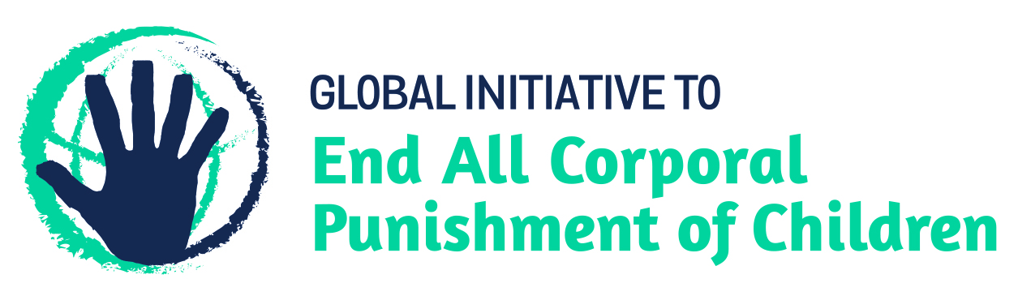
BRIEFING ON LITHUANIA FOR THE HUMAN RIGHTS COMMITTEE, 123rd session (July 2018)
From the Global Initiative to End All Corporal Punishment of Children, June 2018
This briefing provides an update on the legality of corporal punishment of children in Lithuania since the submission of our briefing for the List of Issues Prior to Reporting. We are delighted to inform the Committee that Lithuania has now prohibited corporal punishment in all settings, including the home.
We hope the Committee will, in its concluding observations on Lithuania’s fourth state party report, welcome the explicit prohibition of all corporal punishment of children in Lithuania and recommend that all measures be taken to ensure implementation of the prohibition of corporal punishment in all settings, including the home.

1 Prohibition of all corporal punishment of children in Lithuania
  - During an extraordinary session on 14 February 2017, the Seimas (the Parliament) voted in favour of amendments to the Law on the Fundamentals of Protection of the Rights of the Child 1996, recognising children’s right to be protected from all forms of violence, including corporal punishment. Article 1 of the amending Law edits article 2 of the 1996 Law to include the following definition of corporal punishment (unofficial translation): “any punishment in which physical force is used to cause physical pain, even on a small scale, or otherwise to physically torture a child”. Article 5 amends article 49.1 of the 1996 Law which now states (unofficial translation): “Parents and other legal representatives of the child may appropriately, according to their judgment, discipline the child, for avoiding to carry out his duties and for disciplinary infractions, with the exception of corporal punishment and any other form of violence”. Article 4 of the amending Law recognises children’s right “to be protected from of all forms of violence, including corporal punishment, by their parents, other legal representatives, persons living with them or other persons” (unofficial translation). The amendments came into effect on 21 February 2017.

Updated briefing prepared by the Global Initiative to End All Corporal Punishment of Children
www.endcorporalpunishment.org; info@endcorporalpunishment.org

See the Register of Legal Acts’ website, https://www.e-tar.lt/portal/en/legalAct/48953b10f75111e68034be159a964f47, accessed on 21 February 2017

