Rabat, Morocco
On 20-09-2016
Universal Periodic Review of the People's Democratic Republic of Algeria.
Report of the stakeholder on the issue of the rights of Moroccan workers and their families expelled from Algeria in 1975.
- Introduction:
The Association of Moroccan V ictims of Arbitrary Expulsion from Algeria in 1975 (AMVEAA), a nongovernmental organization founded in July 2006, work in the field of human rights and its main goal advocacy towards governmental and non-governmental organizations is to obtain compensation for the physical and moral damage inflicted to this population by the arbitrary measure held by Algeria in 1975.
AMVEAA intends to challenge the various national and international institutions through the various legal mechanisms available, such as periodic reports on States, international commissions of inquiry, memorandum sent to United Nations commissions, etc.
- Summary of the steps accomplished
The Committee on the Protection of the Rights of All Migrant Workers and Members of Their Families examined on 27 and 28 April 2010 the initial report of Algeria on the measures taken by that country to respect the International Convention for the Protection of Human Rights and Fundamental Freedoms of all migrant workers and members of their families.
Considering that, in the context of this review, the Committee is empowered to ensure the application of the Convention and to convey its concerns and recommendations to the State party in the form of "concluding observations"; The Moroccan Ombudsman for Democracy and Human Rights, through AMVEAA, sent him a memorandum on the deportation of Moroccans from Algeria, which took place from December 1975 and whom rights are still being violated till now.
At the meeting of 26 April 2010, reserved for communication of NGOs on the situation of the rights of migrants in Algeria, The Ombudsman Moroccan, in agreement with (AMVEAA), sent a full report on the atrocious conditions of the arbitrary deportation made to moroccan victims : violent arrests, expropriations, confiscation of goods , degrading behaviors, humiliating insults, rape on women and death of some victims.
Algeria has been questioned about this abuses during the examination of its report before the Committee in question at the April 2010 session and invited to explain the expulsion of Moroccans working legally in Algeria. In her speech as reporter of the Committee, Ms. Myriam Poussi Konsibo rised the fact that “it has been brought to her attention that nearly 350,000 to 500,000 moroccan people have been expelled from Algeria in 1975 in inhumane conditions".
In this regard, the Algerian government has received the following questions:
  - What are the reasons which led to this arbitrary decision?
  - Why the algerian legislation on migrants has not been respected?
  - What is the legal basis for this act of mass deportation of Moroccan citizens?
  - What are the measures taken by the Algerian government to ensure adequate repair of prejudices suffered by the victims?
- Historical context
The Moroccan Ombudsman for Democracy and Human Rights (MDDH) therefore informed UN experts in April 2010, in consultation with AMVEAA, of the situation of the 45,000 families of Moroccans expelled from Algeria.
Indeed, on December 18, 1975, the day of the Aid commemorating the sacrifice of Prophet Abraham, the Algerian government, headed by the late President Houari Boumediene, expelled 45,000 Moroccan families legally established on Algerian territory. These people, integrated for decades in Algeria, were thus deported massively and without warning towards Morocco. The instructions of President Boumediene, carefully considered with his former foreign affairs minister Abdelaziz Bouteflika, actually President of Algeria, reported a planed and massive expulsion (500,000 people) without prior notice and in inhuman conditions for the entire community targed.
Many of these people were sequestered several days in secret jails, deprived of family visits until their expulsion in successive waves spread out over a period of 2 months.
The 45,000 families of Moroccans are dismissed, leaving behind them:
    - part of their family;
    - their movable, immovable and financial assets;
    - their pensions and their wages as workers;
    - their children who, in some cases, were absent at the time of deportation.
Even the Moroccan patients hospitalized in health centers have not escaped from this hunt for Moroccan citizens.
On arriving at the Moroccan borders, the expelled persons were accommodated in tents erected by the Moroccan authorities with the help of the International Red Cross. This temporary shelter will last from a few weeks for some to several years for others. As these thousands of repressed can not be contained in the only border town of Oujda, many of them will then be moved to other cities and regions of the country.
This massive algerian repression has been greatly damaging to the moroccan community .The deportees had great difficulty integrating into Morocco. Indeed, despite their professional integration into civil service employement, most of them still remain in very precarious statement up today.
Minor children were integrated into levels of schooling that do not reflect their real capacity and many will be forced to drop out of school and seek work to help their parents in a precarious situation.
On the housing side, victims who owned single-family houses in Algeria, will have to resort to the renting of unhealthy dwellings given their limited income.
The violations of the fundamental rights of these migrants forcedly deported was legalized by the Algerian authorities in the framework of the Finance law of 2010 which published the official decision of expropriation of the victims and the cancellation of the names of the Moroccan property owners considered "abandoned" by their owners when they were arbitrarily expelled in 1975.
Today, these Moroccan victims demand the support of international human rights bodies for justice and the moral and material damage they have suffered to be repaired by Algerian officials.
On the occasion of the Universal Periodic Review of the State of Algeria by the Human Rights Council and in relation to the Moroccan workers expelled from Algeria in 1975, the Association of Moroccan Victims of Arbitrary Expulsion from Algeria (AMVEAA), notes the following observations in the development of this case:
- The examination of the situation of the State of Algeria in April 2010 by the Committee in charge of the international convention for the protection of migrant workers and their families allowed to officially interpellate the Algerian state on question of harmonizing its legislation and in particular that relating to hard expulsion and remoteness of migrants accordance with articles 22 and 23 of the international convention;
- The Committee has recommended the State of Algeria to adopt all necessary measures for the restitution of property to the expelled migrants in 1975 including the workers between them. The Committee also recommended that these Moroccan victims must be compensated according to article 15 of the abovementioned convention;
- In depit of the UN recommendations and six years after their ediction, there is no indication that the Algerian Government has begun their implementation out;
- In contrast, the Algerian government took the unjust decision in its 2010 budget law (published in the Official Bulletin n° 78 of december 2010) to annex the property of the Moroccan victims massively expelled and ordered the Conservation Fonciry to "remove the names of the properties abandoned by these victims"
4-Recommendations of AMVEAA
In addition to the recommendations of the Committee of Migrant Workers (CMW), which AMVEAA strongly calls for their unconditional application by the Algerian authorities, AMVEAA is asking again, on the occasion of the new UPR on Algeria, the following questions:
- The activation of the implementation of the recommendations made by the UN Committee of migrant workers in 2010;
- The repeal of the provisions of Article 42 of the Finance Act 2010 relating to the expropriation of property of Moroccan workers expelled arbitrarly ;
- The guarantee of admissibility and examination of actions brought by the Moroccan victims inside algerian competent juridictions ;
- The repair of moral and material prejudices suffered by Moroccan workers and their families, victims of arbitrary expulsion in 1975;
- The repair of heavy prejudice suffered by Moroccan citizens incarcerated
in the Algerian jails since 1975 until their liberation in 2012;
- Determination of missing moroccans through the operation of massive deportation in 1975;
- The reestablishment of the Moroccan victims in their pecuniary rights as wages and pensions that the Algerian government did not pay for decades despite their reclamations and bilateral financial conventions in the matter between Morocco and Algeria.

5-Expectations of victims

The next UPR of Algerian State offers once again to AMVEAA the opportunity to return to the charge and to forcefully demand the respect, by the Algerian authorities, of the UN recommendations and their unconditional application.
AMVEAA, as a stakeholder, acting on behalf of all Moroccan victims of the 1975 drama, relies heavily on the sense of justice of the members of the Commission to bring the Algerian government to reason and urge him to correct this monumental and historical error by reestablishing the victims in their rights.

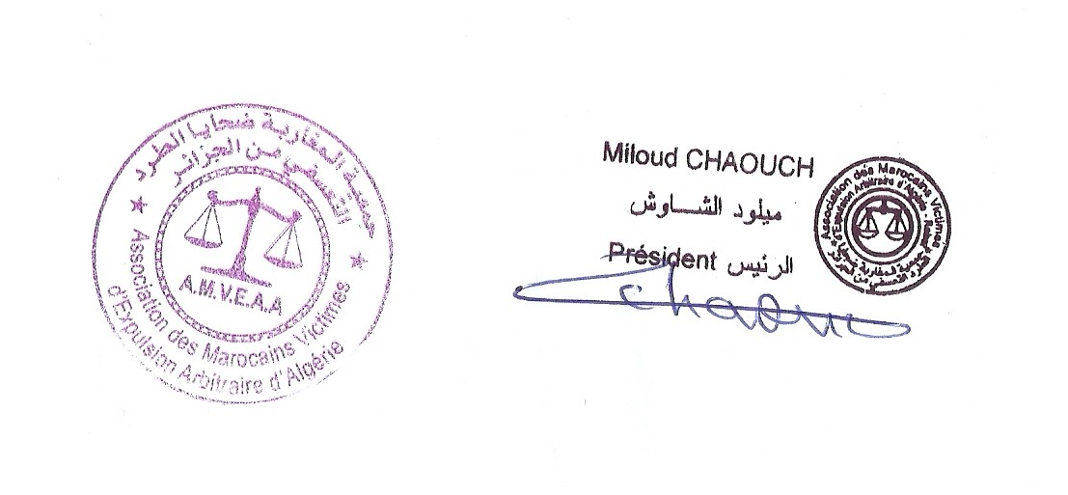

Annex
Extract from the recommendations of the United Nations Committee for the Protection of Migrant Workers and Members of Their Families about Algeria, adopted in April 2010.
24. The Committee takes note of the information on article 42 of the 2010 Finance Act adopted by the State party which permits the final expropriation of abandoned property. While noting the explanation given by the State party's delegation that this provision does not apply to deported migrant workers, the Committee is concerned that the application of this provision could result in the expropriation of the legitimate property of Expelled migrant workers, including Moroccan migrant workers expelled from the State party in the past.
25. The Committee recommends that the State party take all necessary measures to restore the legitimate property of expelled migrant workers, including the Moroccan migrant workers expelled in the past, or to provide fair and adequate compensation in accordance with Article 15 of the Convention.
34. The Committee was informed that several former Moroccan migrant workers continue to be separated from their families following their collective expulsion in the past.
35. The Committee recommends that the State party take appropriate measures to facilitate the reunification of these Moroccan migrant workers with their families who have remained in Algeria.

www2.ohchr.org/english/bodies/cmw/docs/co/CMW-C-DZA-CO1_fr.doc

Annexe
Extrait des recommandations du Comité des Nations Unies pour la protection des travailleurs migrants et des membres de leurs familles à l’intention de l’Algérie, adoptées en avril 2010.

24. Le Comité prend note de l'information relative à l'article 42 de la loi de finances 2010 adoptée par l'État partie qui permet l'expropriation définitive des biens abandonnés. Tout en notant l'explication de la délégation de l'État partie selon laquelle cette disposition ne s'applique pas aux expulsés travailleurs migrants, le Comité est préoccupé que l'application de cette disposition pourrait aboutir à l'expropriation de la propriété légitime des expulsés travailleurs migrants, y compris les travailleurs migrants marocains expulsés de l'État partie dans le passé.
25.Le Comité recommande à l'État partie de prendre toutes les mesures nécessaires pour restituer la propriété légitime des travailleurs migrants expulsés, y compris les travailleurs migrants marocains expulsés dans le passé, ou de leur fournir une compensation équitable et adéquate conformément à l'article 15 de la Convention.
34. Le Comité a été informé que plusieurs anciens travailleurs migrants marocains continuent d'être séparés de leurs familles suite à leur expulsion collective dans le passé.
35. Le Comité recommande à l'État partie de prendre les mesures appropriées pour faciliter le regroupement de ces travailleurs marocains migrants avec leurs familles qui sont restés en Algérie.

www2.ohchr.org/english/bodies/cmw/docs/co/CMW-C-DZA-CO1_fr.doc

