LEGAL

**LEGAL Inc. c/o LIPRIDE Office, ActionAid Compound, Township of**

**Congo Town, Paynesville, Montserrado County, Liberia, West Africa**

**Cell: 0880741192/0770754692/0886496291**

**Email:** [**llegal2012_Liberia@yahoo.com**](mailto:llegal2012_Liberia@yahoo.com)

Shadow Report

**On the Situation of Lesbian, Gay, Bisexual, Trans and Intersex LGBTI Persons in Liberia**

*Submitted for the* ***List of Issues*** *in relation to the initial report of Liberia*

*120th session of the Human Rights Committee (3–28 July 2017)*

***Introduction:***

***The Lesbian and Gay Association of Liberia (LEGAL)*** which came into being on the 26th January 2012, seeks to voice out issues affecting Lesbians, Gays, Transgender, Bi-sexual, Intersex (LGBTI) community, people living with disabilities, HIV, sex workers and female injecting drugs users, in terms of access to social freedom, social justice, social economic empowerment, health, education, equality, freedom of expression, and access to other basic rights services as the fundamental rights of all Liberians under the Constitution of Liberia and the International Treaties.

LEGAL as a Human Rights Based Organization is dedicated to advocating for the wellbeing and protection of the LGBTI community and other discriminated groups in Liberia, for progressive social change, which is aimed at addressing the issues of oppression, discrimination, stigma, abuse, hate crime and limited access to other basic rights services, based on sexual orientation, gender identity, or expression. LEGAL is committed to advancing, gender justice and safe environment for its target groups in Liberia. LEGAL endeavors to promote, provide, foster and enhance access to health, education, social justice, economic empowerment, political participation, and protection for its target groups in Liberia.

**Background**

This shadow report focuses on **violence, abuse and attacks waged against SOGI people, and the criminalization of same-sex conduct** in the Liberian Penal code and the two bills that before the Liberian Parliament breed the vulnerability of the LGBTI community at a high risk of insecurity or jailed or be killed. These laws are in breach of the African Charter[1] and the International Covenant on Civil and Political Rights[2]. This report also describes discriminatory **homophobic media landscape and homophobic public statements** made by official state figures, political leaders, and religious leaders also contradict international human rights law provisions[3]. The criminalization of same-sex conduct and the prevalence of homophobic media coverage and public statements against the LGBTI Community make the environment unsafe. During the Ebola Pandemic, the Media was used to preach hate messages against the LGBTI Community. “Homosexuality is evil, it is based on that GOD sent EBOLA to Liberia” “We will kill them, because they don’t deserve to live”. These statements put the LGBTI Community at the high risk of being attacked or kill.

The two current sodomy bills and the penal code are impeding the livelihood and access to health/rights services for LGBTI people. The LGBTI community members also faced with rejection, lack of freedom of expression, freedom of association, aggression, bulling, castigation, blackmailing, hate crime, stigma, discrimination and abuse in the private and public sectors. Some of them are being drop out of school, college or put out of homes by family, and land laws. They cannot freely assemble or associate as people, these are the major and grieve issues members of the LGBTI community do experience on a daily at the local and levels.

Liberia being a patriarchy and homophobic society promoting an unequal status and protection for the LGBTI community, with a high sentiment of homophobia amongst its citizens against the LGBTI people, makes it difficult for the SOGI Community to access basic human rights services, protection, land ownership, economic agency or participation in decision making at the local and national levels.

However, Liberians who are part of the **LGBTI** community cannot access rights and protection services and are further affected by a **penal code** which criminalizes same sex relations under a sodomy law and also finds it difficult to access basic health services too. For this reason, they are left in closet with no form of redress to their plight. They also face with the issues of discrimination, threats, abuse or violence once sexual orientation and gender identity are expressed. These issues make the LGBTI community more vulnerable of threats to the lager extend. The **penal code** is often used to discriminate against the **LGBTI** community in Liberia whenever members seek for protection services under the law. It further affects their rights to access justice and often perpetrators go free, when members of the LGBTI community are attacked. In extreme cases, victims are jailed.

Liberia being a signatory to a number of International Treaties[4] which are mechanisms that can be used by member’s states signatories to defense its citizens without any forms of discrimination, stigma and abuse based on sexual orientation and gender identities are not being applied fully. In Liberia some of these treaties or conventions are not domesticated, which makes it a challenge for people with different sexualities to access those basic rights and services as enshrined in the international laws or protocols in For example, the penal code (paras 14.73-75) which criminalizes same sex relations, and the two bills that are before the house of parliament, affects LGBTI people to access justice or other rights services at the local and national levels. In some case, when members of the LGBTI community make an effort to access protection whenever their rights are being violated, the case go against them.

The Penal Code of Liberia criminalizes “voluntary sodomy” by same-sex couples but not by opposite-sex couples. The criminalization of same-sex relation is in direct violation of Article 2 of the African Charter, which guarantees the equal enjoyment of the rights of people without any form of discrimination and Article 3, which guarantees equality before the law. Section 14.74 of the Penal Code, entitled “Voluntary Sodomy,” states that it is a first degree misdemeanor to engage in “deviate sexual intercourse under circumstances not stated in Section 14.72 [relating to aggravated involuntary sodomy] or Section 14.73 [relating to involuntary sodomy].” Section 14.79 of the Penal Code defines “deviate sexual intercourse” to mean “sexual contact between human beings who are not husband and wife or living together as man and wife though not legally married, consisting of contact between the penis and the anus”.

In 2012, Representative Clarence Massaquoi **proposed a bill** to the House of Representatives that would amend the Penal Code to make same-sex “sexual practices” a second degree felony, punishable by up to five years in prison. The proposed amendment extends the ban to any action that “arouses or tends to arouse another person of the same gender to have sexual intercourse.” It also applies to any action that “willfully” and with total disregard to societal moral dignity, seduces, encourages, or promotes another person of the same gender to engage into sexual activities.” The bill is before the Judiciary Committee of the House of Parliament. **The second bill**, proposed in 2012 by Senator Jewel Howard-Taylor, would amend the Domestic Relations Law to prohibit same-sex marriage and make violation of the same-sex marriage prohibition a first-degree felony, punishable by a minimum of ten years in prison.

**The Lesbian and Gay Association of Liberia (LEGAL),** seeks to address the plight and advocate for the rights and protection of the LGBTI community so as to create an environment where the **rights** of all will be **respected**, and to have fair **Justice and a voice within the Liberia society**. Because the wellbeing of **LGBTI individuals especially lesbians, Trans women, men, boys and girls** in Liberia must be included in policy. Their **health**, **economic institutions**, **education**, **equality, justice**, and **social** needs, cannot be under estimated, and taking into an account their basic **fundamental rights** serve, as the **cardinal issues** that have to be considered and given serious attention following the years of civil conflict.

**Issues Affecting Lesbians and Gays in Liberia**

The **marginalized** **groupings** in Liberia at a high risk of being insecurity, fear of being attacked, beating, discriminated and stigmatized against all because of their sexualities or the space they find their selves is not safe, despites the limited access to basic health care services, protection, registration of association and other rights services. This situation puts the LGBTI community vulnerability at high risk at the local and national levels in Liberia. If Liberia is to forge ahead as **one people**, **one nation**, with diversity, also taking into consideration the struggle which, **LGBTI,** and other **vulnerable** **groups** are faced with in today’s Liberia is huge and it should draw the attention of the government of Liberia to institute a policy that will seek to address these issues and ensure that health, rights and protection services for all at the local and national levels.

The LGBTI Community is constantly faced with the issues of abuse, attack, stigmatization, discrimination, and domestic violence in the homes, in the streets, rural and urban areas in Liberia. LGBTI persons are face with huge challenges in the Liberian society and they are also the less fortunate and under privilege people who are consider as demonic people and not of GOD. This perception of some members of the Religious community posts a challenge to members of the LGBTI Community to freely access religious services at the local and national levels. These people strive daily for substance to cater to their needs, majorities are unemployed and some are sacked because of their gender identity. They also strive to make their plights heard, but no one wants to listen to their cry because of their sexuality and this is a major challenge for LGBTI people.

***Case examples:*** *In the month of March, 2014, the LGBTI Community was highly hit with hate messages in Churches, Mosques, the media and in the community for the outbreak of EBOLA*

*In the month of July 2014, one of the sisters, A., was attacked and besieged for nine hours, and was threating to be killed, for being a lesbian. This information reached to the documentation desk of LEGAL via phone call, to assist in the process of negotiating for the release of this young lady who worked in the banking sector at the time. Following hours of appealed by LEGAL and one of our protection Officer from the Liberia National Police, the lady in question was released on grounds with a promissory statement not to be around the premises of the attacker. This lady was also dismissed from her job site by her supervisor as her result of her sexuality and presently is unemployed, but contributing to LEGAL’s Finance unit as a Volunteer.*

*In June of this year, B. (27 y.o.), an Outreach officer for LEGAL in one of its target community, called New Kru Town, was attacked with boiled water that damaged one side of her breast. When the case reached to LEGAL via phone, we intervened, and the case was taken to the police and later to the court. During the investigation at the court, the lady who wasted the boiled water on B., was found guilty. Family members came around and appealed to B. to let go the case, they will take care of the hospital bill. B. is also seeking for relocation to another community, outside New Kru Town.*

*Another community member, C., was beating by some unknown guys in the Paynesville Red Light District, about 1hr drive to the city center of Monrovia because of her sexuality.*

*L.P., a member of LEGAL, was thrown outside of her parents’ home because of her sexuality. H. (a Trans boy, 17 y.o.), was thrown out of his parents’ home as the result of his sexuality. Both of them are now seeking shelters.*

LGBTI persons are also being neglected and thrown out of their homes, communities, work places, and the religious or traditional sector.

***Case example:*** *Another instance, a lesbian was working with a reputable entity and was very committed to her job, and responsibility given to her to implement she went to work one morning and her contract was terminated because of her sexuality said her boss at the time. She was called by her boss to ascertain about her sexuality. Her answer was, “I don’t know what you are talking about sir”, and he said I heard that you are a lesbian, and for this reason, your contract will not be renewed. She sought for redress, but there was no one to intervene, because of her sexuality.*

These sort of situations happened in schools and universities, offices, the religious community, where the LGBTI community is threaten and taking into consideration the law that criminalizes same sex relation. Based on these situations members of the LGBTI are always in the hiding position and LEGAL hopes that, issues affecting sexual minority people and other vulnerable groups will be highlighted in policy making in Liberia, and appeal to the government formulate policy that will reduce stigma, abuse, neglect, violence and discrimination against the LGBTI community, using the human rights based approach in post war Liberia.

***Case examples:*** *In recent time, one of the members of the LBT community was killed on the Du-port Road belt by gentlemen who believed to have had a misunderstanding with her concerning her sexuality. This incident occurred on the 16th of November 2016 at mid night. As the result of her death, angry mob reacted on the perpetrator to death which led to the police involvement and as we speak, he is now in prison at the Monrovia Central prison.*

*In January of this year, two of our community members from the old road belt were attacked physically by some guys in his area, on grounds that they are gays. They were beating and our member later took the case to Zone 3 depot for redress. In New Kru Town recently, one of our community members and his mother were assaulted by a police officer because of her son sexuality. As we speak, three of members of the LGBTI community are currently in prison on ground of alleged rape.*

If Liberia is to progress as a nation state, tradition, religion and social norms should include the rights and protection for all as the means of promoting sustainable peace, tolerance, acceptance, development and empowerment and get involve in human rights advocacy process at the local and national levels from a realistic stand point of view.

**Recommendations:**

* The Government of Liberia should:
  + Repeal the **penal code** section 14.75 and 14.79 and stop the passage of the two bills that are pending before the house of parliament that criminalizes same-sex act and imprisonment
  + The Government of Liberia should be more proactive in addressing the protection issues of the LGBTI Community;
  + The Government of Liberia should establish a special desk within the justice and the system that will handle LGBTI related cases without any form of gender discrimination, stigma, abuse or hate
  + Government should institute policy that will reduce hate crime and violence against LGBTI community in Liberia;
  + The Government of Liberia should apply Resolution 275 and other International Treaties so as to address human rights issues in Liberia
  + Government line ministries and entities should fully work with human rights Institutions to strengthen and conduct human rights advocacy training for key Duty Bearers and Community Leaders in the fifteen counties of Liberia so as to create a clear picture on LGBTI issues as human rights issues;
  + Government should institute policy that will allow free access to health care and other rights services for LGBTI persons in Liberia, without any form of gender discrimination, stigma, hate, or abuse;
  + The Liberian Government should enforce the domestication of all International Protocols, declaration or treaties which it has affixed its signatures on, so as to enhance the rights and protection of all Liberian, regardless of their sexualities
  + Government of Liberia should conduct a monthly documentation of Human Rights abuse cases at the local and national levels for redress;
  + The Government should work along with the LEGAL to conduct community needs assessment in the 15 counties to identity other issues affecting the LGBTI Community and identify priorities needs and intervention.
  + The Government of Liberia should conduct speedy trail of alleged sodomy cases at the court level within the 15 Counties of Liberia

**Proposed Questions to the Government of Liberia**

* How does the government of Liberia, intend to address the issues of Religious Fundamentalism, Cultural and Racial Discrimination that are breeding hate crimes, violence, abuse and attack against the LGBTI persons in Liberia?
* Following all the challenges that the LGBTI Community is faced with, in relations to the law, the penal code or the two bills that are before the house of parliament, what mechanism the Government of Liberia intend to use to decriminalizes these laws or proposed bills?
* In terms of access to health care, protection and rights services for the LGBTI Community what the Government of Liberia is doing about this?
* There are members of the LGBTI Community who are been placed in prison since 2010-2016 for alleged sodomy, what the government of Liberia intend to do, so as to provide fair justice and protection for these people who are part of the Country’s Population ?

**Notes:**

1. Criminalization of consensual same-sex relations directly contravenes Article 2 of the African Charter (that guarantees the enjoyment of the rights and freedoms of people without any form of discrimination) and Article 3 of the African Charter (that guarantees equality before the law).
2. See eg *Toonen v Australia*, CCPR/C/50/D/488/1992, communication no. 488/1992, views of 31 March 1994.
3. Homophobic speeches are in violation of the obligation of member state countries to ensure non-discrimination, mutual respect, and tolerance under Articles 2 and 28 of the African Charter.
4. Convention against Torture and Other Cruel Inhuman or Degrading Treatment or Punishment, International Covenant on Civil and Political Rights, International Covenant on Economic, Social and Cultural Rights, Convention on the Elimination of All Forms of Discrimination against Women, International Convention on the Elimination of All Forms of Racial Discrimination, Convention on the Rights of the Child, Convention on the Rights of Persons with Disabilities, Resolution 275 of the African Commission on Human and People’s Rights and other treaties.

   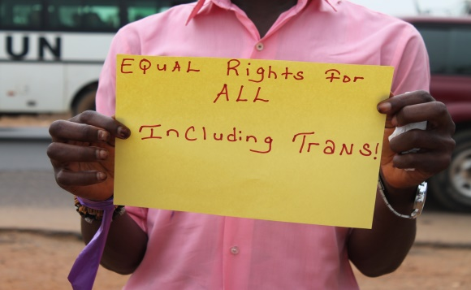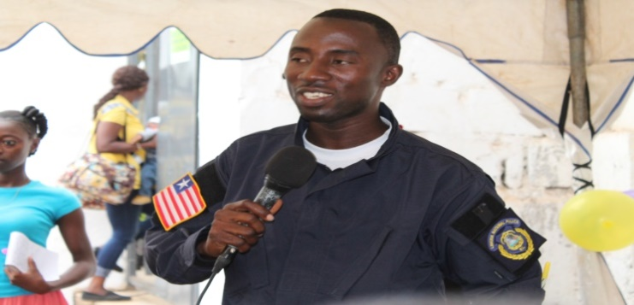

   **Figure 1.** A member of the trans community displaying his message, whilst LEGAL's protection officer providing information on protection issue

   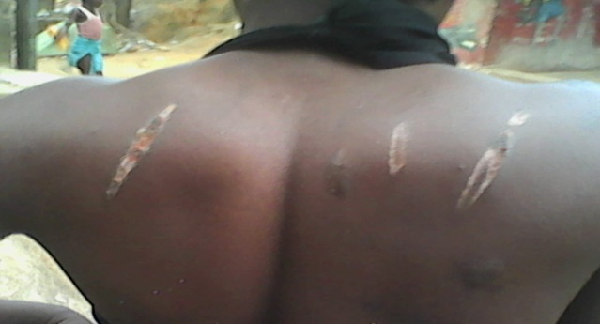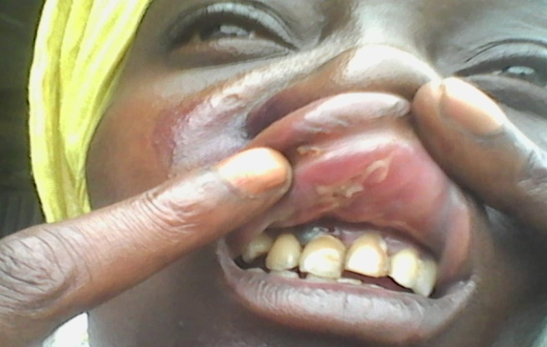

   **Figure 2.** Some members of LEGAL suffered attack at the community level

   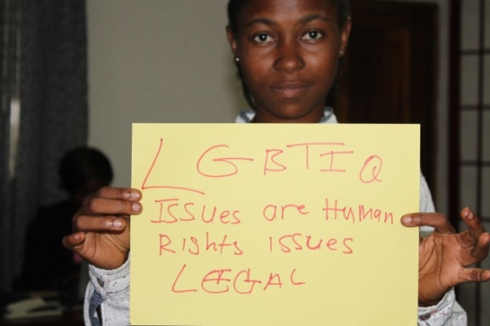

   A member of LEGAL displaying her message